Instructor’s Manual to Accompany
BUSINESS COMMUNICATION
Developing Leaders for a Networked World (4e)

By Peter W. Cardon

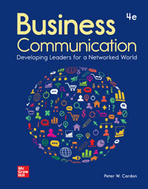

Chapter 1:
Establishing Credibility

Teaching Note

Hello Fellow Instructor,

I believe we’re fortunate to teach this course. It is undoubtedly one of the most important courses our students will take.

We help our students develop many skills in this course that will help them thrive in the workplace.

More fundamentally, we help our students see who they are as people, in a professional and an interpersonal sense. Better yet, we help them see the people who they aspire to be.

I encourage you to use this chapter about credibility to frame this course. I’m sure you have many tried-and-true methods of reaching your students. Try these approaches with your students in terms of credibility and let me know how it goes.

Please contact me any time—to share your experiences, your ideas, and your requests.

Best of wishes,
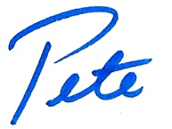
Peter W. Cardon, MBA, Ph.D.
Professor, Department of Business Communication
Academic Director, MBA for Professionals and Managers
University of Southern California

Email: petercardon@gmail.com
Twitter: @petercardon
Facebook: facebook.com/cardonbcomm
Web: connect.mheducation.com

Chapter Summary

This chapter discusses the importance of credibility and how to establish it within business communications. To be a credible communicator, competence, caring, and character is needed. Following business ethics along with corporate and personal values is especially important to forming character. You can evaluate your business communications using the FAIR test (Facts, Access, Impacts, Respect). The rest of the chapters in this textbook will help improve business communication skills in a variety of settings.

PowerPoint Notes and Outline

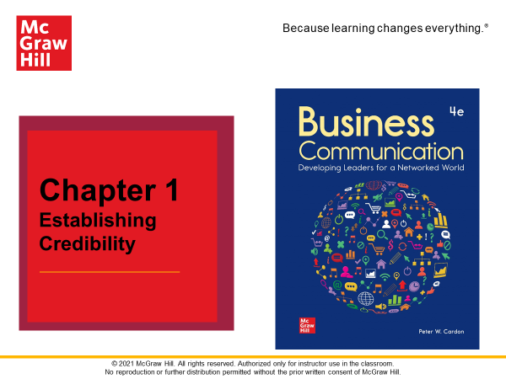 |  | SLIDE 1-1  Chapter 1 Establishing Credibility
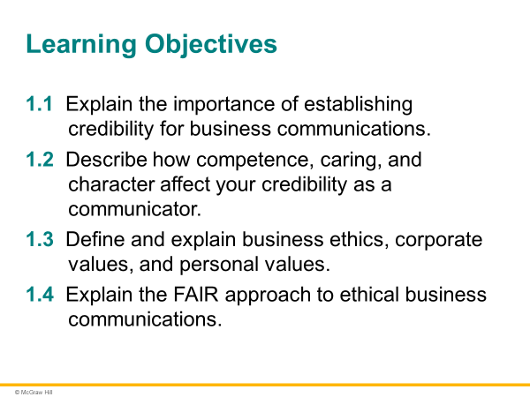 |  | SLIDE 1-2  Learning Objectives
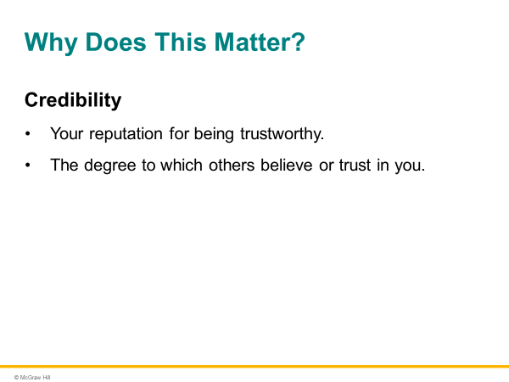 |  | SLIDE 1-3  Credibility is your reputation for being trustworthy—trustworthy to perform your work with excellence; to care about those you work with and for; to live by high ethical, corporate, and personal values; and to deliver on your promises. In short, your credibility is the degree to which others believe or trust in you.
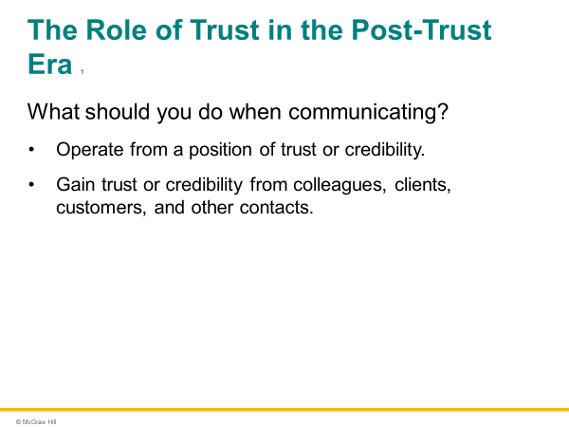 |  | SLIDE 1-4  Do you operate from a position of trust or credibility? That is one of the first things you should consider as you communicate. In the business world, you often start from a deficit of trust. As a result, one of your first goals should be to gain trust or credibility from colleagues, clients, customers, and other contacts.
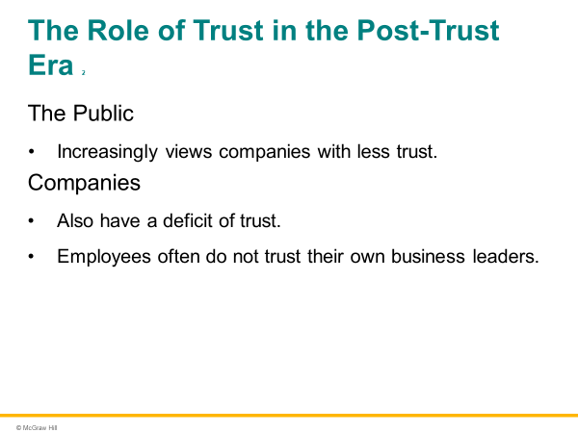 |  | SLIDE 1-5  The public also increasingly views companies with less trust. Approximately 85 percent of senior executives surveyed believe that public trust in business has gone down. A deficit of trust also exists within companies. Various surveys show that employees often do not trust their own business leaders. Just 51 percent of employees trust senior management, and only 36 percent of employees believe that their company leaders act with honesty and integrity. Furthermore, approximately 76 percent of employees have seen illegal or unethical conduct in the past 12 months at their jobs.
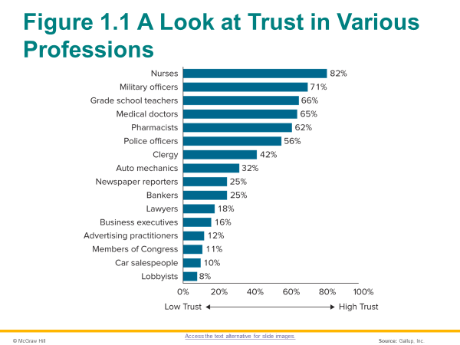 |  | SLIDE 1-6  As depicted in Figure 1.1, the trust extended by the general public to business executives is far lower than the trust extended to members of other selected professions.
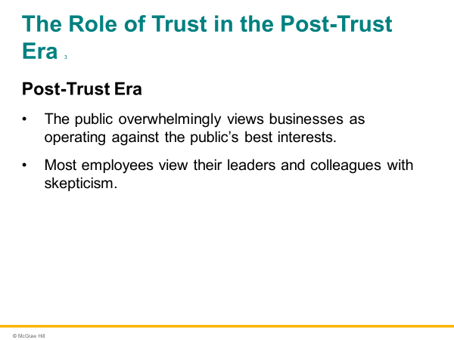 |  | SLIDE 1-7  In the post-trust era, the public overwhelmingly views businesses as operating against the public’s best interests, and the majority of employees view their leaders and colleagues skeptically. Regarding the post-trust era, Michael Maslansky, a leading corporate communications expert, said, “Just a few years ago, salespeople, corporate leaders, marketing departments, and communicators like me had it pretty easy. We looked at communication as a relatively linear process. . . . But trust disappeared, things changed.”
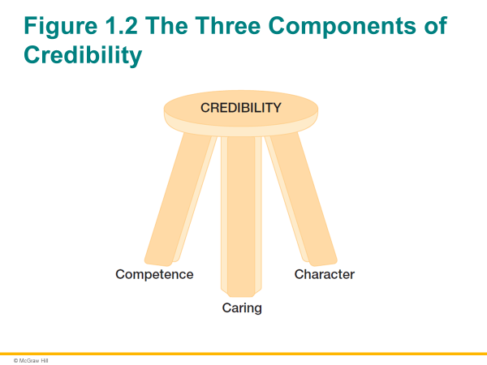 |  | SLIDE 1-8  As a future manager and executive, you can control your reputation as a credible communicator by focusing on three well-established factors: competence, caring, and character. Research has shown that these three factors almost entirely account for whether a person is considered credible in professional situations. As depicted in Figure 1.2, credibility is like a three-legged stool. Without any one element, it is compromised.
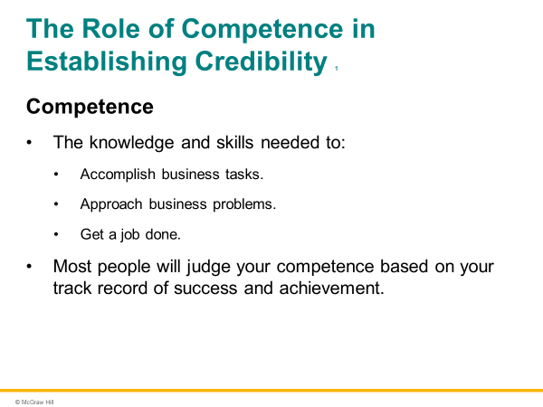 |  | SLIDE 1-9  Competence refers to the knowledge and skills needed to accomplish business tasks, approach business problems, and get a job done. Most people will judge your competence based on your track record of success and achievement. In her memoir, Meg Whitman explains how as a young professional she gained credibility and displayed competence within her organization: “I just focused on delivering results,” she said. “You have to excel at the tasks you’re given and you have to add value to every single project, every conversation where someone seeks your input.”
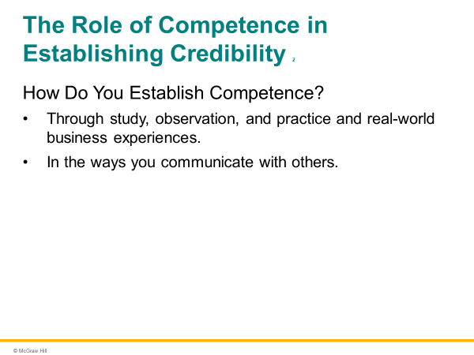 |  | SLIDE 1-10  People develop competence in many ways: through study, observation, and, most importantly, practice and real-world business experiences. Your entire business program is likely centered on developing competence in a certain business discipline or industry. You may already have significant business experience. If you’re a novice, seeking internships and jobs related to your discipline will help you develop competence. How you communicate directly affects the perceptions others have of your competence.

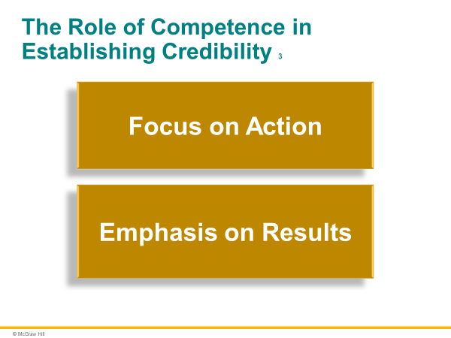 |  | SLIDE 1-11  Throughout this book, you will find an emphasis on two traits associated with competence: a focus on action and an emphasis on results. A focus on action implies that you seize business opportunities. Meg Whitman emphasized this action-oriented approach to work: “The way I usually put it is, the price of inaction is far greater than the cost of making a mistake. You do not have to be perfect to be an effective leader, but you cannot be timid.” She also described an emphasis on results: “I don’t believe that all a company needs to do is declare that it has values and then say, ‘Trust us, we know what’s best.’ To be a success, you must identify a goal with a measurable outcome, and you must hit that goal—every day, every month, every year.”
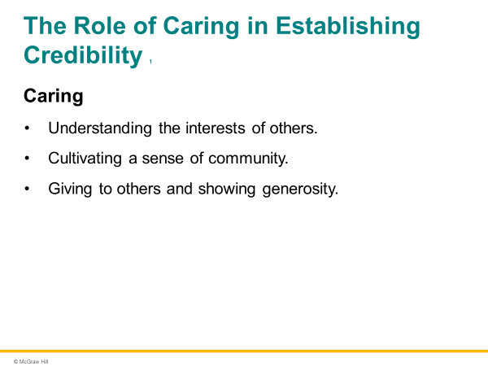 |  | SLIDE 1-12  Your colleagues, clients, and even your customers will trust you far more if they know you care about them. In the business world, caring implies understanding the interests of others, cultivating a sense of community, and demonstrating accountability. People distrust individuals who are perceived as unconcerned about the interests of others or disinterested in causes above and beyond themselves.
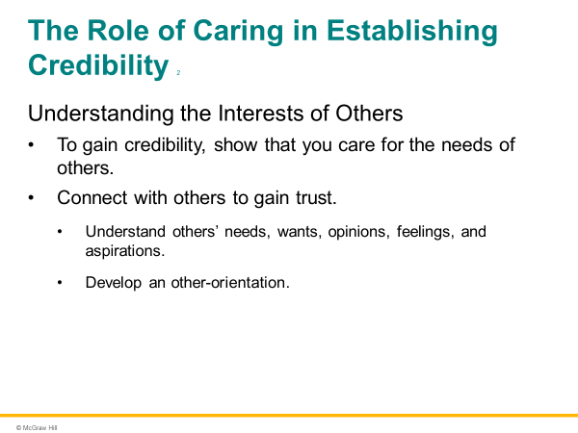 |  | SLIDE 1-13  Your ability to gain credibility strongly depends on your ability to show that you care for the needs of others. Furthermore, your ability to show you care puts you in a rare position as a business leader. After all, less than half (42 percent) of employees believe that their managers care about them. Effective communicators gain trust by connecting with others—that is, seeking to understand others’ needs, wants, opinions, feelings, and aspirations. Virtually every aspect of communication you will focus on in this book relies on this other-orientation.
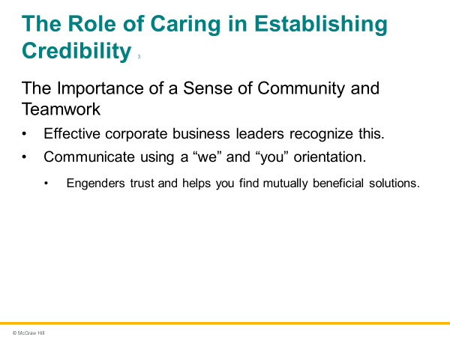 |  | SLIDE 1-14  The most effective business leaders in today’s corporate environment have generally risen to their positions because of their sense of community and teamwork. Throughout this textbook, you will see techniques for communicating your “we” and “you” orientation rather than a “me” orientation. Speaking about “our needs” or “your needs” as opposed to “my needs” engenders trust and helps you come up with solutions that achieve mutual benefit.
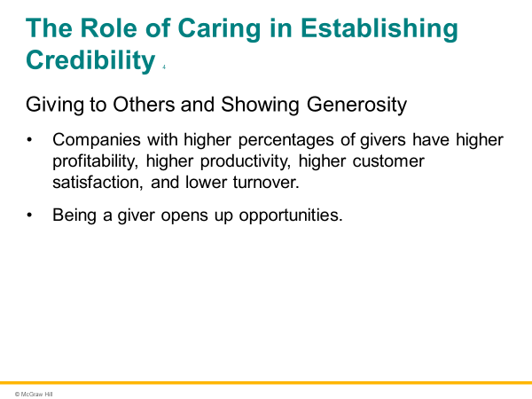 |  | SLIDE 1-15  Recent research has shown that most professionals can broadly be characterized as givers and takers. Givers are those professionals who go out of their way to help colleagues, respond to their requests and needs, and generously support others in the workplace. Takers are those professionals who frequently ask for favors from colleagues yet infrequently volunteer to help their peers in return. Dozens of studies in recent years show that organizations with more generous and giving employees perform better. Such companies achieve higher profitability, higher productivity, and higher customer satisfaction.
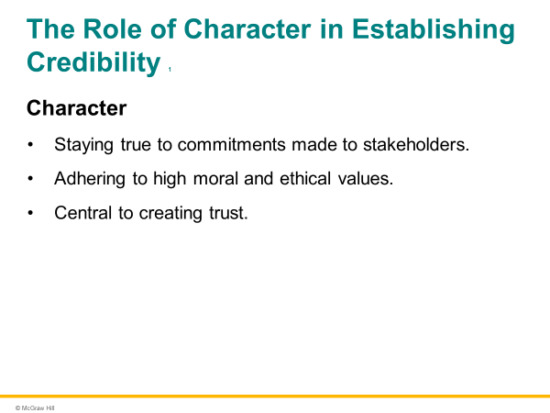 |  | SLIDE 1-16  Character refers to a reputation for staying true to commitments made to stakeholders and adhering to high moral and ethical values. Character has always been important in business relationships, especially long-term, collaborative relationships. It is becoming even more important—especially for leaders—in an increasingly open, transparent, connected, and interdependent workplace.
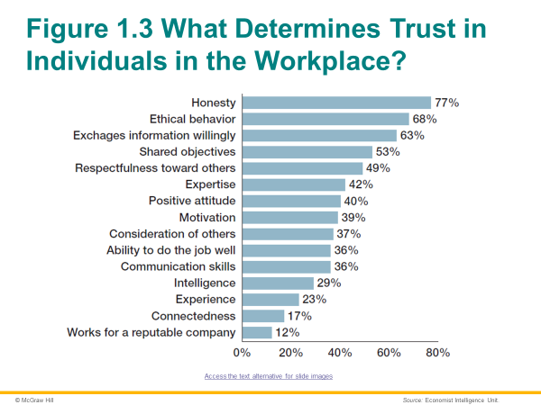 |  | SLIDE 1-17  Character is central in creating trust. Consider the recent research, depicted in Figure 1.3. Business executives were asked what the most important determinants of trust in workplace projects were. Overwhelmingly, character-based traits—that is, honesty, ethical behavior, willingness to exchange information—ranked at the top.
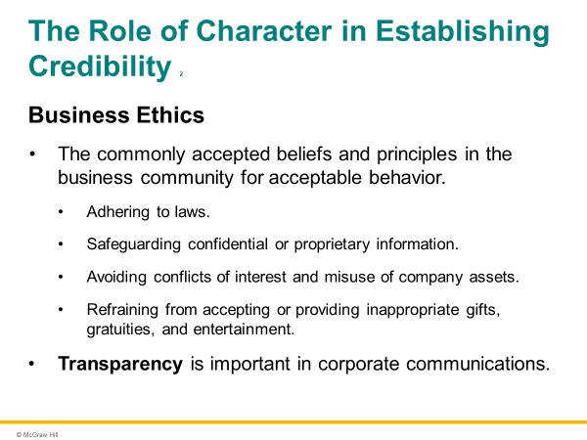 |  | SLIDE 1-18  Business ethics are the commonly accepted beliefs and principles in the business community for acceptable behavior. At a minimum, business ethics involve adhering to laws; safeguarding confidential or proprietary information; avoiding conflicts of interest and misuse of company assets; and refraining from accepting or providing inappropriate gifts, gratuities, and entertainment. Transparency involves sharing all relevant information with stakeholders. You will soon be in leadership positions within your organization. You can create a transparent workplace by being accessible, acknowledging the concerns of others, and following through when you don’t have immediate answers.
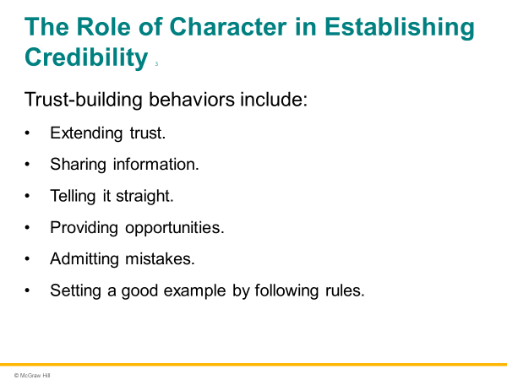 |  | SLIDE 1-19  Trust-building behaviors include extending trust, sharing information, telling it straight, providing opportunities, admitting mistakes, and setting a good example by following rules.
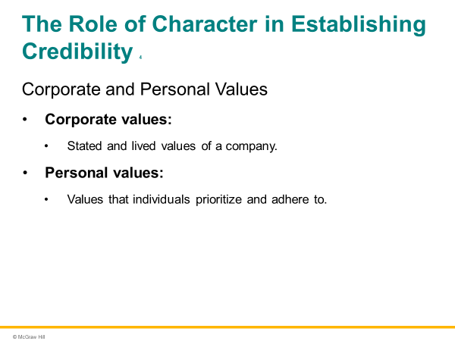 |  | SLIDE 1-20  Corporate values are the stated and lived values of a company. The Society for Human Resource Management espouses corporate values as the essence of business ethics. It defines business ethics as “organizational values, guidelines, and codes,” and it emphasizes “behaving within those boundaries when faced with dilemmas in business or professional work.  Personal values are those values that individuals prioritize and adhere to. If one is living corporate values that do not match one’s personal values, then there is a lack of integrity.
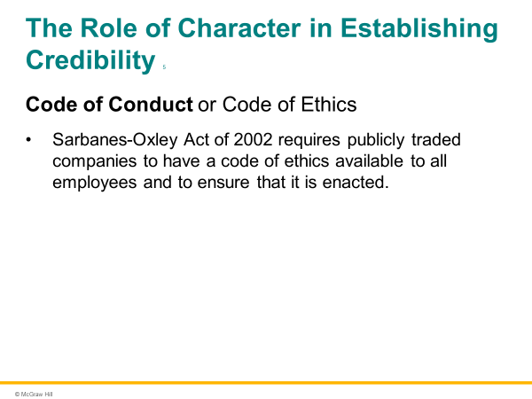 |  | SLIDE 1-21  Most organizations have created a written code of conduct or code of ethics. Publicly traded companies are required by the Sarbanes-Oxley Act of 2002 to have a code of ethics available to all employees and to ensure that it is enacted. For example, eBay’s culture of trust is embodied in its Code of Business Conduct & Ethics. It encourages employees that “beyond complying with the law… [they] can Do the Right Thing.” It encourages them to “be open, honest and direct and conduct business with integrity” and “encourage open communication free from the threat of retaliation.”
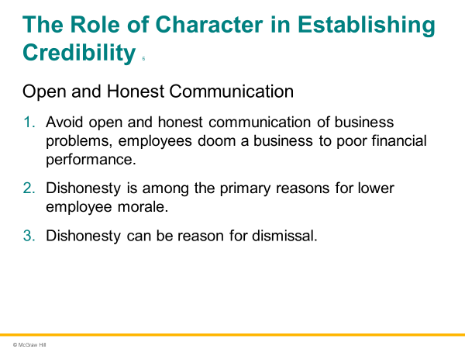 |  | SLIDE 1-22  By avoiding open and honest communication of business problems, employees doom a business to poor financial performance. Also, dishonesty is among the primary reasons for lower employee morale. Nearly six in ten employees say that they’ve left an organization because of lack of trust—the key reasons being lack of communication and dishonesty. Finally, dishonesty can be reason for dismissal. In some cases, dishonesty can destroy careers and even result in criminal charges.
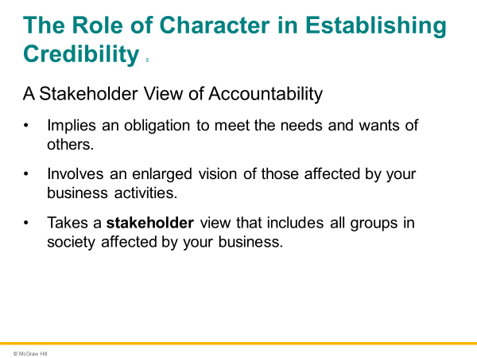 |  | SLIDE 1-23  A sense of accountability implies an obligation to meet the needs and wants of others. It also involves an enlarged vision of those affected by your business activities. It takes a stakeholder view that includes all groups in society affected by your business activities. Thus, a sense of accountability involves a feeling of responsibility to stakeholders and a duty to other employees and customers. By placing a rationale for accountability in your communications, you will generate substantial trust and goodwill from others.
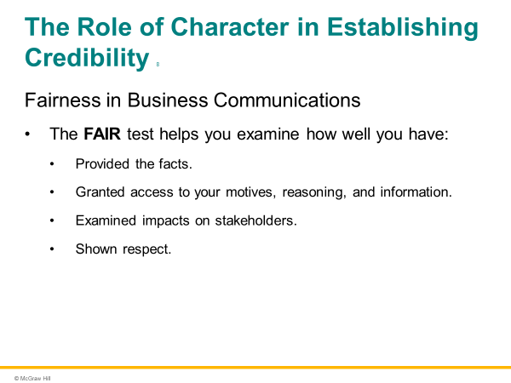 |  | SLIDE 1-24  The FAIR test helps you examine how well you have provided the facts; how well you have granted access to your motives, reasoning, and information; how well you have examined impacts on stakeholders; how well you have shown respect. As you respond to these questions, you ensure that your communications are fair to yourself and others.
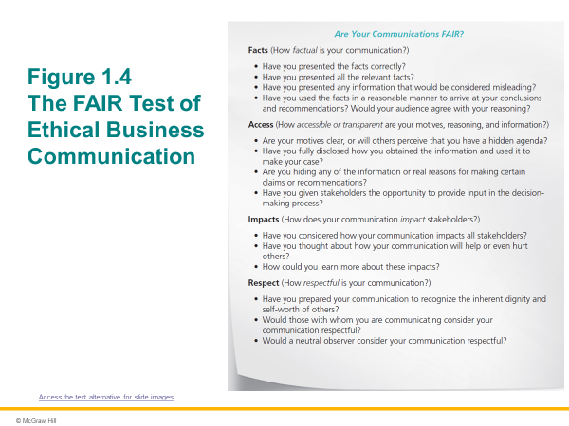 |  | SLIDE 1-25  In all your communications, you should consider whether you are being fair to others. For routine communications, you make this calculation quickly. For important, less straightforward, and perhaps even controversial communications, you should spend a significant amount of time evaluating the best way to be fair. You might consider talking to your supervisor, peers, and other trusted individuals to appraise the situation.
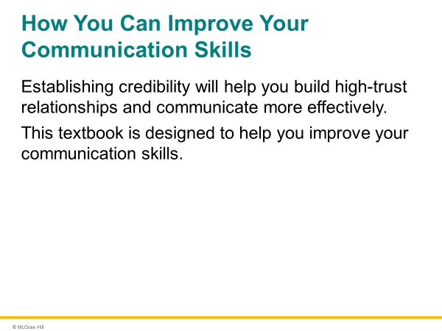 |  | SLIDE 1-26  Establishing credibility allows you to communicate more easily and more influentially. Extensive research has shown that high-trust relationships lead to more efficient and superior work outcomes. In terms of ease of communication, credibility leads to less resistance from others, increased willingness to cooperate, and less likelihood of miscommunication. In high-trust relationships, since individuals willingly and freely give the benefit of the doubt, communication is simpler, easier, quicker, and more effective.
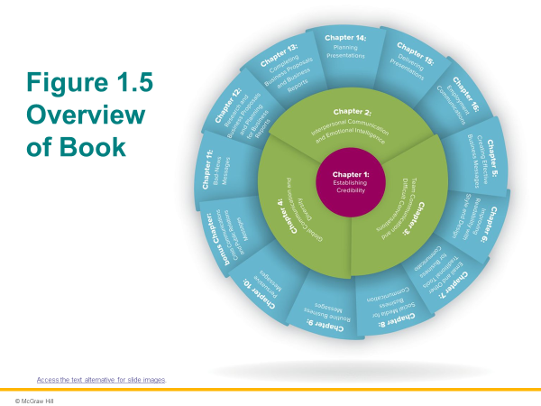 |  | SLIDE 1-27  This textbook is designed to help you improve your skills in a variety of professional settings so that you can become a credible and trusted communicator. Overall, you may feel that you excel at some communication skills but not others. Regardless of your present skill level, this textbook gives you opportunities to deliberately and consciously elevate your communication skill set. It also gives you tools to continue developing your communication abilities over the course of your career. Figure 1.5 provides an overview of the topics we will cover in this textbook.

Solutions to Discussion Exercises

In these suggested approaches and solutions, you’ll find key points to look for in students’ responses.

  - Chapter Review Questions (LO 1.1, LO 1.2, LO 1.3, LO 1.4)

Answer each of the following questions with one to three paragraphs:
- Explain the importance of establishing credibility in business communications.
Important parts of this answer could include the following: (a) Other people judge your comments, presentations, emails, and other communications based on your personal credibility. When you are viewed as credible, your messages are viewed as more plausible. When you are not viewed as credible, others will doubt your messages. (b) As a business professional, you often operate from a position of distrust. By establishing personal credibility, you are more likely to gain trust in your messages and other communications.
- Explain the three components of credibility: competence, caring, and character. How do they interrelate?
This answer should include short explanations about each aspect of credibility. Competence involves skills and knowledge to accomplish work tasks. Caring involves understanding and showing interest in the professional and personal needs of others. Character involves adhering to high ethics and values. The second part of this discussion item involves explaining how these aspects of credibility are interrelated. Students should be rewarded for mentioning how these aspects overlap in some situations, especially when they provide specific instances. For example, asking others to participate in a meeting may be viewed as competence and caring. It shows skill at running an effective meeting. It shows caring because of a sincere interest in the views of others.
- Define and explain business ethics, corporate values, and the relationship between them.
Business ethics are the commonly accepted beliefs and principles in the business community for acceptable behavior. Corporate values are the stated and lived values of a company. The text explains that the Society for Human Resource Management has defined corporate values as the essence of business ethics. Students should be rewarded for providing nuanced answers about cases where corporate values may not align with commonly accepted beliefs and principles in the business community within an industry or even more broadly.
- Explain the FAIR approach to evaluating ethical business communications.
The FAIR approach helps professionals ask key questions to evaluate whether their communications are ethical. By asking questions related to facts, access, impacts, and respect, professionals can get a good sense of whether they are truly being fair to others. Students should be rewarded for providing examples from their school and work experiences.
- Describe how credibility impacts communication efficiency and effectiveness.
Credibility makes communication more effective and efficient because each person in a high-trust relationship tends to put up less resistance to the ideas of others in the relationship. The persons in a high-trust relationship also tend to give each other the benefit of the doubt when misunderstandings arise.

  - Ideas in Action (LO 1.1, LO 1.2, LO 1.3, LO 1.4)

Read the Ideas in Action with Mary Barra of GM, and write a one- or two-paragraph response to each of the following questions:
- What points does Mary Barra make about the impact of competence in establishing credibility?
Ms. Bara has a proven track record of results, so she urges GM employees to develop their skills and be forward-looking with their solutions.
- What points does she make about the impact of caring in establishing credibility?
Ms. Barra encourages professionals to focus on the needs of others and build long-term, meaningful relationships. She stresses the role relationships play in business.
- What points does she make about the impact of character in establishing credibility?
She promotes honesty, transparency, and high values ("your North Star"). Leaders develop real integrity during rough times. Values must mean more than words on a page, you have to do what you say you are going to do.
- Which of her comments or experiences do you view as particularly insightful or helpful? Why that one?
Answers will vary.

  - Character and Rules (LO 1.2)

As a former chair of the U.S. Federal Reserve once said, “Rules cannot take the place of character.” In two to three paragraphs, explain what you think he meant by this statement.
Responses will vary. Key points/angles may include: (a) ethical behavior cannot be forced upon professionals; (b) professionals must have their own moral compasses; or (c) rules cannot account for all ethical dilemmas.

  - Transparency (LO 1.3)

As Drs. Dennis S. Reina and Michelle L. Reina explained in their book Trust and Betrayal in the Workplace, “Some leaders assume that … they are obligated to tell employees only what they specifically need to do their job. This couldn’t be further from the truth.” In three to five paragraphs, explain the meaning of this statement. Why might leaders provide information about their activities and decision making, even when employees may not be directly affected?
Responses will vary. Key points/angles may include: (a) employees will follow leaders who they believe share information and decision-making openly with them; (b) an open and honest work environment leads to higher morale and productivity; or (c) employees who know more about their organizations and its leaders will be more engaged.

  - Gather Information from Websites about Ethics in Business (LO 1.3)

Read at least three blogs or articles about trust and/or ethics from a reputable organization or other source. Choose an issue that interests you, and in four to five paragraphs, summarize key findings related to that issue.
Responses will vary widely. Students should be rewarded for choosing specific and challenging topics.

1.6 Watch Interviews with Business Executives about Corporate Values (LO 1.2, LO 1.3)

Watch at least three videos of interviews with executives talking about corporate values. In four to five paragraphs, summarize what you learned.
Responses will vary widely. You may need to help students find useful and current interviews with executives. See the textbook website (connect.mheducation.com) and Facebook page (facebook.com/cardonbcomm) for options.

1.7 Learn About Corporate Citizenship (LO 1.3)

In recent years, companies have increasingly focused on their social responsibility. Many companies refer to the actions they take to help or give back to society as corporate citizenship. Learn about corporate citizenship from at least three reliable organizations or sources. In four to five paragraphs, summarize what you’ve learned.
Responses will vary widely. Students should be rewarded for choosing specific and challenging topics.

1.8 Identify Specific Approaches to Corporate Citizenship (LO 1.3)

Choose a company and analyze its corporate citizenship measures. In four to five paragraphs, explain the company’s major corporate citizenship initiatives and how they reflect its core values. Generally, you can find a corporate citizenship page at a company’s website by navigating within sections with titles such as “About Us,” “Company Overview,” “Public Relations,” “Media,” and so on.
Responses will vary widely. You might direct students to particular companies. Most public companies create annual corporate social responsibility (CSR) reports, which are nearly always housed on their websites. You might also direct students to corporate Facebook pages, YouTube channels, or other outlets where CSR initiatives are often publicized.

1.9 Business Ethics and Changing Values (LO 1.3)

David Pottruck, former president and co-CEO of the Charles Schwab Corporation, explained the following regarding ethics and law:
At Schwab, we are constantly looking for new ways to express our values without compromising them. For example, we built the company on the principle of “no conflict of interest.” For many years, we defined that principle as “we will not give investment advice,” because we equated advice with the old-line practice of selling hot stocks to maximize brokerage commissions. When we found that our customers were demanding advice from us, we realized that our business model, one that did not compensate brokers for sales, made it possible for us to give advice and continue to avoid conflict. We changed our practice to give the customers what they wanted, expert advice that is “objective, uncomplicated and not driven by commission,” and at the same time we strengthened our commitment to our values. We feel that was a highly responsible change.
In three to five paragraphs, discuss whether you think corporate and personal values can and/or should change over time. Specifically discuss Pottruck’s statements.
Responses will vary widely here. Consider rewarding students for providing a nuanced view of this issue, such as giving examples where expressions of values vary over time and examples where expression of values do not change over time. For example, students might argue that values such as ensuring the safety of employees by having no workplace accidents is a constant expression of a value. On the other hand, they might argue that values such as providing fair compensation to employees remain constant but that what constitutes fair compensation will naturally evolve over time.

1.10 Watch Ted Talks about Credibility and Trust (LO 1.1, LO 1.2, LO 1.3)

Watch a TED Talk about credibility and trust. Write three to five paragraphs about the following:
- A brief summary (four to five sentences) of the talk.
- Two or three insights about credibility.
- Two or three related recommendations for how professionals can act with higher credibility.
Answers will vary.

Solutions to Evaluation Exercises

In these suggested approaches and solutions, you’ll find key points to look for in students’ responses.

1.11 Compare Two Individuals’ Credibility (LO 1.1, LO 1.2)

Think about two people—one whom you trust implicitly and another whom you do not trust. Ideally, these should be two people you currently work with or have worked with in the past. Compare them in the following ways: (a) competence, (b) caring, (c) character, (d) openness of communication, and (e) ease of communication. Write four to five paragraphs. Conclude with several general statements about the impact of credibility on communication efficiency and effectiveness.
Responses will vary widely. You might prompt students to do the following for this exercise: (a) make sure they are constructive with their comments; (b) choose individuals from the workplace or school if possible; and/or (c) use pseudonyms to protect the identity of others if they feel the information is sensitive.

1.12 Assess Credibility (LO 1.1, LO 1.2)

Think about four people: (a) a person who lacks complete credibility because he or she lacks competence, (b) a person who lacks credibility because he or she lacks caring, (c) a person who lacks credibility because he or she lacks character, and (d) a person with complete credibility. Compare and contrast these four individuals in terms of communication effectiveness in the workplace.
Responses will vary widely. You might prompt students to do the following for this exercise: (a) make sure they are constructive with their comments; (b) choose individuals from the workplace or school if possible; and/or (c) use pseudonyms to protect the identity of others if they feel the information is sensitive.

1.13 Evaluate a Communication Event (LO 1.1, LO 1.2)

Choose two communication events (conversations, email exchanges, and so on) that you were involved in—one in which you had credibility from the perspective of others and one in which you did not. If possible, choose communication events that occurred in the workplace or at your university. Respond to the following items about these two events:
- Provide an overview of each communication event.
- Explain the results of each event in terms of ease of communication and accomplishment of workplace objectives.
- Explain why in one situation others granted you credibility but not in the other.
- For the situation in which you had less perceived credibility, think about how you might have better established trust. Write down three ways you could have done so before the communication event occurred.
Responses will vary widely. You might prompt students to do the following for this exercise: (a) make sure they are constructive with their comments; (b) choose individuals from the workplace or school if possible; and/or (c) use pseudonyms to protect the identity of others if they feel the information is sensitive.

1.14 Examine Personal Credibility (LO 1.2)

Think about a specific professional context, and respond to each of the following questions. For the context, you can use a current or previous job. Or you could use a professional or student activity in which you participated. Ideally, you will select a context with challenging cooperation issues.
- How much do/did others trust you in this situation?
- How credible are/were you in terms of competency, caring, and character (from the perceptions of others)?
- Do you think you are/were being perceived inaccurately in any ways? Why?
- Have you done/did you do anything that may have broken trust in any way?
- Have you kept/did you keep all your agreements? Explain.
- List three things you need to do or should have done to better establish credibility.
Responses will vary widely. I’ve found that some students are hesitant to share personal information if they think it might be shared with other classmates. You might consider telling the students that you will be the only person who sees this assignment and that you won’t share it with anyone.

Alternatively, if you intend to have peers share the information with one another, you might consider telling them to write only about information they are comfortable sharing with classmates.

1.15 Apply the FAIR Test (LO 1.4)

Choose a recent communication event (conversation, email exchange, and so on) that you were involved in, observed, or heard about. If possible, choose a communication event that occurred in the workplace and that involved a challenging ethical problem. Analyze the communication event with the FAIR test of ethical business communication. Devote at least one paragraph to each aspect of the test: (a) facts (how factual was the communication?); (b) access (how accessible or transparent were the motives, reasoning, and information?); (c) impacts (how did the communication impact stakeholders?); (d) respect (how respectful was the communication?).
Responses will vary widely. You might prompt students to do the following for this exercise: (a) make sure they are constructive with their comments; (b) choose individuals from the workplace or school if possible; and/or (c) use pseudonyms to protect the identity of others if they feel the information is sensitive.

1.16 Apply the FAIR Test to a Customer Letter (LO 1.4)

Using the FAIR test, evaluate Tim Cook’s open letter to customers (published as “A Message to our Customers” on February 16, 2016, on the Apple website: www.apple.com/customer-letter). Address each aspect of the FAIR test: (a) facts (how factual was the communication?); (b) access (how accessible or transparent were the motives, reasoning, and information?); (c) impacts (how did the communication impact stakeholders?); (d) respect (how respectful was the communication?).
Responses will vary widely. Student answers must cover all aspects of the FAIR test: facts, access, impacts, and respect. Students should be rewarded for specificity in their evaluation.

1.17 Apply the Fair Test to a Media Interview (LO 1.4)

Using the FAIR test, evaluate a Wall Street Journal interview with Tim Cook (“Tim Cook Defends Apple’s Encryption Policy” on YouTube: (www.youtube.com/watch?v=BZmeZyDGkQ0) about resistance to a U.S. court order to help unlock a terrorist’s iPhone. Address each aspect of the FAIR test: (a) facts (how factual was the communication?); (b) access (how accessible or transparent were the motives, reasoning, and information?); (c) impacts (how did the communication impact stakeholders?); (d) respect (how respectful was the communication?).
Responses will vary widely. Student answers must cover all aspects of the FAIR test: facts, access, impacts, and respect. Students should be rewarded for specificity in their evaluation.

Solutions to Application Exercises

In these suggested approaches and solutions, you’ll find key points to look for in students’ responses.

1.18 Personal Mission Statement and Code of Conduct (LO 1.3)

Write your own mission statement, including a code of conduct. Consider the following steps as you create the statement:
- Find several companies you admire. Use their code of conduct statements to help you craft your personal statement. Make sure you’ve personalized the statement to capture your deepest values and goals.
- Go to a career development website. These websites often contain articles and blogs about creating personal statements. For example, see the following:
  - “The Five-Step Plan for Creating Personal Mission Statements” by Randall S. Hansen (www.quintcareers.com/creating_personal_mission_statements.html)
  - “Writing a Personal Mission Statement” by Rodger Constandse (www.timethoughts.com/goalsetting/mission-statements.htm)
  - “How to Write a Personal Mission Statement” (www.daveramsey.com/blog/mission-statement-101)
- Go to a consultant website specializing in mission statements. Usually, these websites provide free resources for developing your own statement. In some cases, you will be required to create a username and password, but the online assistance is free. For example, see FranklinCovey’s step-by-step guide (www.franklincovey.com/msb/).
Responses will vary widely. You might ask students to work in teams initially and brainstorm about what they’d like to include in their personal statements. You might also consider asking students to share their personal statements with small groups or with the entire class. Finally, you might consider asking students to modify their personal statements at the end of the semester after they’ve spent several months developing their communication skills and career aspirations.

1.19 Statement of Career Aspirations (LO 1.3)

When asked “What’s your career advice for young people?” Vineet Nayar, former CEO of HCL Technologies, a $5 billion IT services company centered in India, said the following:
When you come out of college, you’re raw. You have energy. You want to experiment. You want to learn. You have hopes. You have aspirations. You want to be Oprah Winfrey. You want to be Steve Jobs. You want to be Bill Gates. You want to be all that. Slowly, over time, you lose it. And by looking in the mirror every day as you get older, you fool yourself that you’re OK. There has to be another way of looking in the mirror and revisiting what you really want to do. So I would say, maybe at the end of college, write it down honestly, in 100 words or whatever it is, and put it in a box. I call it the magic box. Revisit it once a year or once every two years and say, how honest are you to that? Don’t let anybody run your life. That, in my mind, is very, very important. You should be in control of your life.
Think about what Nayar’s comments mean for you. In approximately 100 to 200 words, describe your deepest career aspirations. Include several statements about your guiding philosophy and the core personal values that drive your ambitions. Explain who you want to be in the future. Write the statement assuming that you will return to it in five, ten, or more years to see what progress you have made with your self-determined career aims.
This is not an easy assignment for many students. Many of them have not thought deeply about these issues. Tell the students that being certain is not essential. Rather, by committing their thoughts about their goals—however undeveloped they may be—to a document, they are pushing themselves to become strategic and purposeful about their career directions. Over time, these ideas will evolve. You might even consider asking them to return to this exercise at the end of the semester.

Solutions to Language Mechanics Check

1.20 Review the comma rules C1 through C4 in Appendix A. Then, rewrite each sentence to add commas where needed.

- Financial advisors who have CFA certification can provide better advice. (C1)
- Janice and Jim Atkinson, who are certified financial advisors, pay attention to your unique investment situation. (C1)
- Janice received her CFA certification at the same time that I did. (C1)
- Janice Atkinson, president of Atkinson Financial, will speak at the next Chamber of Commerce event. (C2)
- Level 1 of the CFA exam focuses on ethical standards, and Level 2 focuses on security valuation and portfolio management. (C4)
- Janice spent almost three months preparing on her own for the CFA exam but still didn’t pass it on her first try. (C4)
- As a result, she took a workshop in portfolio management from one of the top local experts. (C3)
- Janice received her CFA certification last year, the same time that I did. (C1)
- Janice specializes in retirement planning and Jim specializes in tax preparation. (C4)
- Jim, not Janice, prepares all their slide decks. (C2)

Connect Application Exercise Support

Evaluating Professional Credibility

Activity Summary: This activity helps students understand the three key elements of professional credibility: competence, caring, and character. Understanding each of these elements will help students identify ways that they can become more credible to others.
Type: Case Analysis
Learning Objectives:
Learning Objective: 01-02 Describe how competence, caring, and character affect your credibility as a communicator.
Difficulty Level: 1 Easy
Blooms: Understand
AACSB: Communication
Follow-Up Activity: Create a list of various kinds of jobs. Break students into small groups and assign each group one job. Ask them to make a brief list of ways a person in this job might demonstrate competence, caring, and character to establish credibility with coworkers and customers. Have them share their results with the class.

Credibility as a Communicator

Activity Summary: This activity helps students identify actions that demonstrate the three different elements of credibility: competence, caring, and character. In the exercise, students click and drag the behaviors that demonstrate each element into the correct column. (Note: A keyboard accessible version of this activity is also available.)
Type: Click and Drag
Learning Objectives:
Learning Objective: 01-02 Describe how competence, caring, and character affect your credibility as a communicator.
Learning Objective: 01-03 Define and explain business ethics, corporate values, and personal values.
Learning Objective: 01-04 Explain the FAIR approach to ethical business communications.
Difficulty Level: 2 Medium
Blooms: Analyze
AACSB: Communication; Ethics
Follow-Up Activity: Instructors could ask for volunteers to provide specific examples of each of these behaviors. Students should be encouraged to think of examples that occur within business settings.

Reviewing Communications with the FAIR Test

Activity Summary: This activity teaches students about the FAIR test for evaluating if communications are fair and ethical. FAIR stands for facts, access, impacts, and respect. In the exercise, students click and drag the behaviors that demonstrate these four categories into their correct columns. (Note: A keyboard accessible version of this activity is also available.)
Type: Click and Drag
Learning Objectives:
Learning Objective: 01-03 Define and explain business ethics, corporate values, and personal values.
Learning Objective: 01-04 Explain the FAIR approach to ethical business communications.
Difficulty Level: 3 Hard
Blooms: Evaluate
AACSB: Communication; Ethics
Follow-Up Activity: Instructors could present examples of communications that do not pass the FAIR test and call on students to identify which categories of the test the communications fail to meet.

Credibility for a Young Manager

Activity Summary: In this activity, students view a ten-minute video and then answer a series of multiple-choice questions about the case. The video features a young project manager having a meeting with three demoralized employees. The questions focus on the ways that the manager demonstrates, or fails to demonstrate, the three aspects of credibility: competence, caring, and character.
Type: Video Case
Learning Objectives:
Learning Objective: 01-02 Describe how competence, caring, and character affect your credibility as a communicator.
Learning Objective: 01-03 Define and explain business ethics, corporate values, and personal values.
Learning Objective: 01-04 Explain the FAIR approach to ethical business communications.
Difficulty Level: 3 Hard
Blooms: Evaluate
AACSB: Communication; Ethics
Follow-Up Activity: Instructors could lead a further discussion of what the manager did well when it comes to establishing her credibility and what the manager could have done better. Students should be encouraged to consider all three aspects of credibility.

Credibility for an Entry-Level Professional

Activity Summary: This activity teaches students about the real-world implications of credibility for young professionals. They must analyze the credibility of three audit assistants described in a case study and then answer multiple-choice questions about the assistants. Each of the assistants demonstrates strength in one of the three aspects of credibility—competence, caring, and character—but shows weakness in another aspect.
Type: Case Analysis
Learning Objectives:
Learning Objective: 01-02 Describe how competence, caring, and character affect your credibility as a communicator.
Learning Objective: 01-03 Define and explain business ethics, corporate values, and personal values.
Learning Objective: 01-04 Explain the FAIR approach to ethical business communications.
Difficulty Level: 2 Medium
Blooms: Analyze
AACSB: Communication; Ethics
Follow-Up Activity: Students could be encouraged to further explore the impact of credibility through a role-play exercise. Assign them into groups of three and have them play the parts of the three audit assistants. The three characters should have a conversation about the ways in which each assistant's lack of credibility affects the work of the other two.

