N10-008 Network+ Instructor’s Test Bank (Chapters 1-25)
(updated by Michael D. Taylor, Feb 2023)
Answer:and Explanation
References when used
Chapter Links For Production Convenience
1, 2, 3, 4, 5, 6, 7, 8, 9, 10, 11, 12, 13, 14, 15, 16, 17, 18, 19, 20, 21, 22, 23, 24, 25
Notes:
- Many questions were moved from one chapter into another one if it was appropriate. You will see this noted often.
- Other questions were not directly covered in the chapter, but are still considered important concepts to know for the Network+ exam and were topically related to the chapter content. Those were moved to the end of the chapter and noted as ‘Bonus Questions’. Whether you include them or not is up to you. I recommend using them to make the test bank for effective to students actually taking the certification.
- Finally, where many questions were removed from a chapter, leaving too few questions, additional questions were created from chapter content where possible. Some chapters are short.

Chapter 1: OSI Model
1. At which OSI layer can a source MAC address be found in the Ethernet header?
- Network layer
- Transport layer
- Physical layer
- Data link layer
Answer: d. Data link layer
2. The option of sending a group of segments at one time, instead of just one segment at a time, is provided at what layer of the OSI reference model?
- Data link layer—using link aggregation
- Network layer — using multiprotocol routing
- Transport layer— using Windowing
- Physical layer—using interface bonding
Answer: c. Transport layer—using Windowing
Explanation: The key word was segments, a datagram term found at the Transport layer
3. The source IP address can be found in the header of a packet at this layer of the OSI reference model
- Network layer
- Session layer
- Data link layer
- Transport layer
Answer: a. Network layers
4. Which of the following is a connectionless network layer protocol?
- IP
- TCP
- UDP
- SFTP
Answer: a. IP
Explanation: UDP and TCP are Transport Layer. IP is Network layer and can only be made connection oriented if coupled with TCP. When IP is coupled with UDP it is considered connectionless.
5. What is the protocol of the address used by a router (at Layer 3) to identify specific devices?
- MAC
- IP
- LLC
- ARP
Answer: b. IP
Explanation: The Internet Protocol (IP) address is used by routers (at Layer 3) to identify specific devices on a network. This type of address, as opposed to a MAC address, is used across routed devices (routers) (that is, the IP address typically does not change when traffic flows through a router).
6. Which of the following can sequence a received set of segments correctly to reassemble a data stream?
- UDP
- FTP
- ICMP
- TCP
Answer: d. TCP
7. Which of the following correctly describes encapsulation as opposed to decapsulation?
- The data moves from the physical layer to application layer
- A header is added at the beginning of a packet.
- The frame header and trailer are stripped off
- The packets are sent to the transport to be reassembled.
- A port number is identified and the data associated with an application.
Answer: b. A header is added at the beginning of a packet.
Explanation: As data moves down through the OSI model layers (on a host) it is encapsulated with a header at each OSI Layer whether it be a segment, packet, or frame.
8. Which layer of the OSI reference model enforces the Maximum Transmission Unit (MTU) size allowed for transmitted frames?
- Network layer
- Transport layer
- Physical layer
- Data Link Layer
Answer: d. Data link layer
9. A Protocol Data Unit (PDU) refers to payload data with metadata fields that describe how the data needs to be handled by the different OSI layers. What is the name of the PDU in the physical layer of the OSI reference model?
- Segment
- Frames
- Bits
- Packet
Answer: c. Bits
10. Which of the following is not a characteristic of the Media Access Control (MAC) sublayer of the data link layer (Layer 2) of the OSI reference layered model?
- The MAC sublayer uses a physical address called a MAC address, which is a 48-bit (6-byte) address assigned to a device network interface card.
- Layer 2 devices transmit to logical network addresses.
- Method of transmitting on the media.
- The use of flow control on a network to prevent a receiver from being overwhelmed.
Answer: d. The use of flow control on a network to prevent a receiver from being overwhelmed.
11. Which of the following layers of the OSI reference model is primarily concerned with forwarding data based on logical addresses?
- Physical layer
- Data link layer
- Network layer
- Presentation layer
Answer: c. Network layer
12. Which of the following transport layer protocol of the OSI reference model is a connection-oriented protocol that provides reliable transport between two communicating hosts?
- Transmission Control Protocol (TCP)
- Transport Control Protocol (TCP)
- User datagram Protocol (UDP)
- Internetwork Packet Exchange (IPX)
Answer: a. Transmission Control Protocol (TCP)
13. Which OSI reference model layer is responsible for the following?
- Setting up a session
- Maintaining a session
- Tearing down a session
- Presentation layer (Layer 6)
- Data link layer (Layer 2)
- Session layer (Layer 5)
- Transport layer (layer 4)
Answer: c. Session layer (Layer 5)
14. ABC Corporation is changing the format of text from American Standard Code for Information Interchange (ASCII) to Extended Binary Code Decimal Interchange Code (EBCDIC). They also requested that confidential files on servers be protected by applying an appropriate encryption. What OSI reference model layer is responsible for formatting the data encryption?
- Presentation layer (Layer 6)
- Data-link layer (Layer 2)
- Session layer (Layer 5)
- Transport layer (Layer 4)
Answer: a. Presentation layer (Layer 6)
15. Which of the following layers is not identified with the TCP/IP protocol stack?
- Transport
- Application
- Presentation
- Internet
Answer: c. Presentation
Explanation: TCP/IP includes ‘Presentation’ within its application layer.
16. What layer of the OSI corresponds to label A and B?
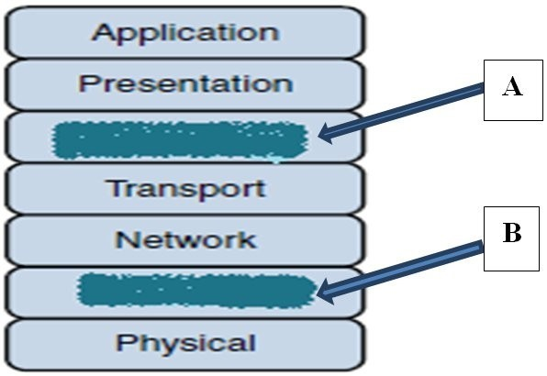
- A is the host-to-host layer, and B is the Internet access layer.
- A is the session layer, and B is the application layer.
- A is the session layer, and B is the data link layer.
- A is the session layer, and B is the physical layer.
Answer: c. A is the session layer, and B is the data link layer.
17. Given the two displays below, what are they?
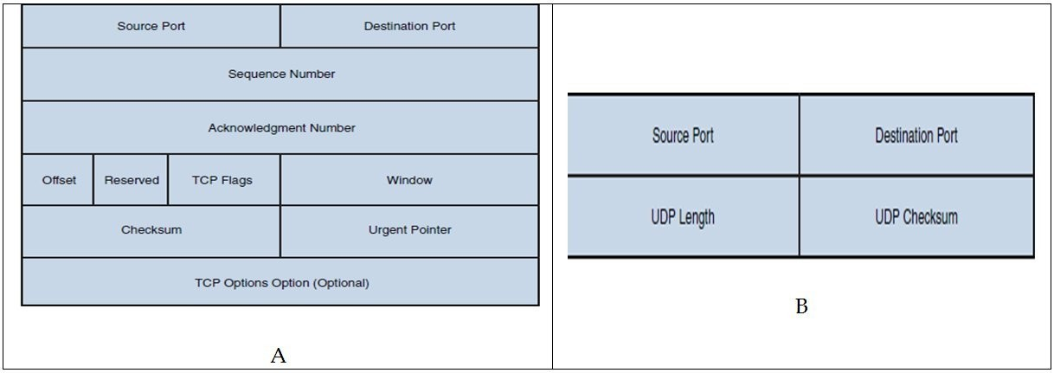
- A is UDP segment format, and B is a TCP segment format.
- A is a TCP segment format, and B is a UDP segment format.
- A is IPX segment format, and B is a Session layer format.
- A is SPX segment format, and B is a IPX segment format.
Answer: b. A is a TCP segment format, and B is a UDP segment format.
Explanation: UDP is designed for efficient delivery over a high reliability path. When that is a needed requirement, the lack of sequence number or acknowledgements does not significantly affect a transmission. As an example, UDP would be preferred over TCP in a live streaming event.
18. What is the name of the mechanism used by TCP to increase and decrease the number of segments that are sent between each other before an acknowledgment is required?
- Buffering
- Synchronizing
- Scaling
- Windowing
Answer: d. Windowing
Explanation: TCP uses a mechanism called windowing to control the number of segments that are sent between one device and another before an acknowledgment is required. This "window" slides (or adjusts) as the available bandwidth between devices increases and decreases based on a negotiation between devices.
19. What is the name of the address that is used by a switch to identify specific devices?
- MAC
- IP
- LLC
- ARP
Answer: a. MAC
Explanation: The Media Access Control (MAC) address is used by switches (at Layer 2) to identify specific devices. This address is typically set by the hardware manufacturer. This address is used for LAN communications only and is not used across routed (routers) devices (that is, the MAC addresses change when traffic flows through a router). It is possible to figure out the manufacturer of a network interface card (NIC) on a network by performing an analysis of the MAC address it is using to communicate.
20. Which type of transmission synchronization technique uses start and stop bits at the beginning and end of a data frame?
- Synchronous
- Isochronous
- Asynchronous
- Biochronous
Answer: c. Asynchronous
Explanation: There are three methods of performing synchronization: isochronous, asynchronous, and synchronous. When using asynchronous, the data frame is encased within a start and stop bit. This lets the receiver know of its location within a traffic stream.
21. Which approach to data transmission consumes all the available signal space/frequencies on a cable to transmit data?
- Broadband
- Baseband
- Time-division multiplexing
- Simplex
Answer: b. Baseband
Explanation: As opposed to Broadband, which uses frequencies to share the cable, baseband occupies the entire width of the cable, i.e, a square sine wave.
22. The _____________ is the data that is being encapsulated by the various OSI layer headers that are used to direct it to a destination.
- Segment
- Byte
- Payload
- Packet
Answer: c. Payload
Explanation: The purpose of the headers is to create meta data that can be used to ensure proper and efficient delivery of the data payload
23. Which of the following is a function within the Data Link layer of the OSI model?
- Packaging of frames with a header
- Performing error detection
- Uniquely locating remote MAC addresses
- All of the above
Answer: d. All of the above
Explanation: The Data Link layer does all of these and also handles flow control and ensures that frames do not exceed the MTU size.
24. Which kind of segment header contains field information known as ‘flags’ relevant to tracking the state in which a connection exists, whether it is open or closed?
- TCP
- UDP
- Port
- Frame CRC
Answer: a. TCP
Explanation: The TCP header has a ‘flags’ field. The UDP header does not use as field to track session states. The other Answers are not relevant to the question.
Bonus Question
25. Which IEEE standard defines wired Ethernet as it is used on modern networks?
- 802.5
- 802.16
- 802.3
- 802.1
Answer: c. 802.3
Explanation: Ethernet as it is used on modern networks is defined within the IEEE 802.3 standard. Other common IEEE standards included 802.1 (bridging), 802.2 (LLC), and 802.11 (wireless Ethernet).

