Package Title: Test Bank
Course Title: Derrickson 2e
Chapter Number: 1

Question Type: Multiple Choice

1) All of the following statements are true according to cell theory EXCEPT

a) a cell is the basic unit of life
b) organisms are made of at least one cell
c) cells are formed from other cells
d) organs are made of a single type of cell

Answer: d

Difficulty: Easy
Bloom’s: Comprehension
Learning Objective 1: LO 1.1 Define physiology, identifying several of its subdisciplines.
Section Reference: 1.1 Physiology Defined

2) A skeleton has been found that appears to be human in origin. What features would you expect it to have?

a) small skull and use of two limbs for movement
b) use of four limbs for movement and erect posture
c) erect posture and large skull
d) small skull and four limbs for movement

Answer: c

Difficulty: Medium
Bloom’s: Application
Learning Objective 1: LO 1.1 Define physiology, identifying several of its subdisciplines.
Section Reference: 1.1 Physiology Defined

3) Which would be an example of physiology?

a) identification of a new bone
b) documenting the physical area where a heart is damaged
c) tracing the blood vessels used from an organ to the heart
d) explaining how a neuron conducts a signal

Answer: d

Difficulty: Medium
Bloom’s: Application
Learning Objective 1: LO 1.1 Define physiology, identifying several of its subdisciplines.
Section Reference: 1.1 Physiology Defined

Question type: Text Entry

4) Someone who studies the kidneys would be a/an ____ physiologist.

Answer: renal

Difficulty: Easy
Bloom’s: Knowledge
Learning Objective 1: LO 1.1 Define physiology, identifying several of its subdisciplines.
Section Reference: 1.1 Physiology Defined

Question type: Multiple choice

5) Which is an incorrect pairing of a structure-function relationship?

a) a thick layer of cells in an organ allowing exchange
b) a wide tube in an area where lots of flow is needed
c) strong bones in an area that bears more weight
d) elastic tissue in areas that stretch frequently

Answer: a

Difficulty: Medium
Bloom’s: Application
Learning Objective 1: LO 1.1 Define physiology, identifying several of its subdisciplines.
Section Reference: 1.1 Physiology Defined

6) Select the molecule from the options below.

a) N
b) H₂O
c) O₂
d) H₂O and O₂

Answer: d

Difficulty: Medium
Bloom’s: Application
Learning Objective 1: LO 1.2 Explain how the organization of the human body affects its functions and life processes.
Learning Objective 2: LO 1.2.1 Describe the levels of organization that make up the human body.
Section Reference: 1.2 Levels of Organization in the Body

Question type: True/False

7) Proteins and RNA are examples of atoms.

Answer: False

Difficulty: Easy
Bloom’s: Comprehension
Learning Objective 1: LO 1.2 Explain how the organization of the human body affects its functions and life processes.
Learning Objective 2: LO 1.2.1 Describe the levels of organization that make up the human body.
Section Reference: 1.2 Levels of Organization in the Body

Question type: Multiple choice

8) Place the levels of organization in order from MOST to LEAST complex.

a) organismal, system, organ, tissue, cell, molecule, atom
b) organ, system, cell, atom, molecule, organismal, tissue
c) atom, molecule, cell, tissue, organ, system, organismal
d) cell, tissue, organ, organismal, system, atom, molecule

Answer: a

Difficulty: Easy
Bloom’s: Knowledge
Learning Objective 1: LO 1.2 Explain how the organization of the human body affects its functions and life processes.
Learning Objective 2: LO 1.2.1 Describe the levels of organization that make up the human body.
Section Reference: 1.2 Levels of Organization in the Body

Question type: Text Entry

9) Skin is an example of ___ tissue.

Answer: epithelial

Difficulty: Medium
Bloom’s: Application
Learning Objective 1: LO 1.2 Explain how the organization of the human body affects its functions and life processes.
Learning Objective 2: LO 1.2.1 Describe the levels of organization that make up the human body.
Section Reference: 1.2 Levels of Organization in the Body

Question type: Multiple choice

10) If one is unable to move, even if the tissue is directly stimulated, the first tissue to check would be

a) epithelial tissue
b) connective tissue
c) muscle tissue
d) nervous tissue

Answer: c

Difficulty: Medium
Bloom’s: Application
Learning Objective 1: LO 1.2 Explain how the organization of the human body affects its functions and life processes.
Learning Objective 2: LO 1.2.1 Describe the levels of organization that make up the human body.
Section Reference: 1.2 Levels of Organization in the Body

11) Which of the following is a defining feature of organs?

a) they are composed of two or more different atoms
b) they are composed of two or more different cells
c) they are composed of two or more different molecules
d) they are composed of two or more different tissues

Answer: d

Difficulty: Easy
Bloom’s: Knowledge
Learning Objective 1: LO 1.2 Explain how the organization of the human body affects its functions and life processes.
Learning Objective 2: LO 1.2.1 Describe the levels of organization that make up the human body.
Section Reference: 1.2 Levels of Organization in the Body

12) Fluids are not circulating around the body, so the problem is most likely due to the ____ systems.

a) muscular and endocrine
b) cardiovascular and lymphatic
c) immune and skeletal
d) respiratory and digestive

Answer: b

Difficulty: Medium
Bloom’s: Application
Learning Objective 1: LO 1.2 Explain how the organization of the human body affects its functions and life processes.
Learning Objective 2: LO 1.2.2 Explain the functions of the eleven body systems.
Section Reference: 1.2 Levels of Organization in the Body

13) The gonads, epididymis, vas deferens, uterus, and vagina are all organs that are part of the _____ system, the main function of which is _____.

a) endocrine; formation of a new organism
b) reproductive; formation of a new organism
c) urinary; removal of wastes
d) integumentary; protects the body

Answer: b

Difficulty: Easy
Bloom’s: Comprehension
Learning Objective 1: LO 1.2 Explain how the organization of the human body affects its functions and life processes.
Learning Objective 2: LO 1.2.2 Explain the functions of the eleven body systems.
Section Reference: 1.2 Levels of Organization in the Body

Question type: Text Entry

14) An emergent property of the ____ system is physical breakdown and absorption of nutrients.

Answer: digestive

Difficulty: Medium
Bloom’s: Application
Learning Objective 1: LO 1.2 Explain how the organization of the human body affects its functions and life processes.
Learning Objective 2: LO 1.2.2 Explain the functions of the eleven body systems.
Section Reference: 1.2 Levels of Organization in the Body

Question type: Multiple choice

15) Integration between the ____ systems allows the body to maintain pH homeostasis.

a) respiratory and urinary
b) endocrine and cardiovascular
c) immune and lymphatic
d) integumentary and immune

Answer: a

Difficulty: Medium
Bloom’s: Application
Learning Objective 1: LO 1.2 Explain how the organization of the human body affects its functions and life processes.
Learning Objective 2: LO 1.2.2 Explain the functions of the eleven body systems.
Section Reference: 1.2 Levels of Organization in the Body

16) Which of the following situations would most likely have the greatest increase in catabolic reactions compared to anabolic reactions occurring in the body?

a) an athlete going through pre-season conditioning
b) a person on a hunger strike
c) a child going through a rapid growth spurt
d) an individual maintaining a healthy eating and exercise plan

Answer: b

Difficulty: Medium
Bloom’s: Analysis
Learning Objective 1: LO 1.3 Identify the important life processes of the human body.
Section Reference: 1.3 Life Processes

17) You are watching a cooking show when your stomach suddenly rumbles. This is an example of the life process of

a) responsiveness
b) movement
c) differentiation
d) reproduction

Answer: a

Difficulty: Easy
Bloom’s: Application
Learning Objective 1: LO 1.3 Identify the important life processes of the human body.
Section Reference: 1.3 Life Processes

18) We consider movement to have been observed if it occurs at the ____ level.

a) intracellular
b) organismal
c) organ
d) All of the choices are correct.

Answer: d

Difficulty: Easy
Bloom’s: Comprehension
Learning Objective 1: LO 1.3 Identify the important life processes of the human body.
Section Reference: 1.3 Life Processes

19) Select the correct relationship between growth and reproduction.

a) both occur when an individual cell increases in size
b) both occur when total numbers of cells increase
c) both occur only when two half-cells merge
d) both occur when the substances around the cells increase in volume

Answer: b

Difficulty: Medium
Bloom’s: Analysis
Learning Objective 1: LO 1.3 Identify the important life processes of the human body.
Section Reference: 1.3 Life Processes

20) Many compounds in our body are regulated to maintain homeostatic levels. Which of the following would NOT be maintained in homeostasis?

a) oxygen
b) glucose
c) temperature
d) carbon dioxide
e) All of the choices are normally maintained in homeostasis.

Answer: e

Difficulty: Easy
Bloom’s: Knowledge
Learning Objective 1: LO 1.4 Explain how homeostasis is maintained in the body's internal and external environments.
Learning Objective 2: LO 1.4.1 Define homeostasis.
Section Reference: 1.4 Homeostasis

21) The urinary and respiratory systems rely on the cardiovascular system to circulate the blood with which they exchange wastes and gases. This reliance is an example of

a) equilibrium
b) emergent properties
c) integration
d) differentiation

Answer: c

Difficulty: Medium
Bloom’s: Application
Learning Objective 1: LO 1.2 Explain how the organization of the human body affects its functions and life processes.
Section Reference: 1.2 Levels of Organization in the Body

22) Approximately how much of the total body fluid is comprised of plasma?

a) 1/3 * 1/5 = 1/15 (6.6%)
b) 1/3 * 4/5 = 4/15 (26.6%)
c) 2/3 * 1/5 = 2/15 (13.3%)
d) 2/3 * 4/5 = 8/15 (53.3%)

Answer: a

Difficulty: Medium
Bloom’s: Analysis
Learning Objective 1: LO 1.4 Explain how homeostasis is maintained in the body's internal and external environments.
Learning Objective 2: LO 1.4.2 Distinguish between the body's internal environment and external environment.
Section Reference: 1.4 Homeostasis

23) A 200 pound lean male (60% fluid) has about ___ lbs of interstitial fluid.

a) 32
b) 8
c) 16
d) 64

Answer: a

Difficulty: Medium
Bloom’s: Analysis
Learning Objective 1: LO 1.4 Explain how homeostasis is maintained in the body's internal and external environments.
Learning Objective 2: LO 1.4.2 Distinguish between the body's internal environment and external environment.
Section Reference: 1.4 Homeostasis

24) The body’s internal environment is composed of

a) intracellular fluid
b) extracellular fluid
c) air surrounding the body
d) interstitial fluid only

Answer: b

Difficulty: Easy
Bloom’s: Knowledge
Learning Objective 1: LO 1.4 Explain how homeostasis is maintained in the body's internal and external environments.
Learning Objective 2: LO 1.4.2 Distinguish between the body's internal environment and external environment.
Section Reference: 1.4 Homeostasis

25) Blood capillaries have anatomical features to increase the transfer between plasma and interstitial fluid to maintain homeostasis. What structural features would you expect would help?

a) few capillaries
b) great distance between cells and capillaries
c) thin walls
d) fewer capillaries with thin walls

Answer: c

Difficulty: Medium
Bloom’s: Application
Learning Objective 1: LO 1.4 Explain how homeostasis is maintained in the body's internal and external environments.
Section Reference: 1.4 Homeostasis

26) The body uses the nervous and endocrine systems to regulate homeostatic changes, but the endocrine is much slower. This occurs because

a) hormones travel via neurons, which only go to a few places in the body
b) hormones travel via blood, and it takes longer for the blood to reach all the cells of the body
c) hormones travel via the lungs, so they can only reach the body during inspiration
d) hormones travel as electrical signals and they disappear quickly, so not all signals reach the organs

Answer: b

Difficulty: Easy
Bloom’s: Comprehension
Learning Objective 1: LO 1.4 Explain how homeostasis is maintained in the body's internal and external environments.
Section Reference: 1.4 Homeostasis

27) Feedback systems maintain homeostasis by monitoring and responding to changes in a parameter. The monitored parameter maintained in a homeostatic state is called the

a) effector
b) receptor
c) control center
d) controlled variable

Answer: d

Difficulty: Easy
Bloom’s: Knowledge
Learning Objective 1: LO 1.4 Explain how homeostasis is maintained in the body's internal and external environments.
Learning Objective 2: LO 1.4.3 Describe the components of a feedback system.
Section Reference: 1.4 Homeostasis

Question type: Text entry

28) A disruption to a controlled variable is called a stimulus. The stimulus interacts with a/an _____ to activate a feedback system.

Answer: receptor

Difficulty: Easy
Bloom’s: Comprehension
Learning Objective 1: LO 1.4 Explain how homeostasis is maintained in the body's internal and external environments.
Learning Objective 2: LO 1.4.3 Describe the components of a feedback system.
Section Reference: 1.4 Homeostasis

Question type: Multiple choice

29) Oxygen levels have decreased during a period of exercise, leading to an increase in respiration rate. In the feedback system that regulates blood gasses, the lungs are acting as the

a) receptor
b) control center
c) stimulus
d) effector

Answer: d

Difficulty: Medium
Bloom’s: Application
Learning Objective 1: LO 1.4 Explain how homeostasis is maintained in the body's internal and external environments.
Learning Objective 2: LO 1.4.3 Describe the components of a feedback system.
Section Reference: 1.4 Homeostasis

30) In a feedback system, the effector typically affects the variable that served as a stimulus. Based on that, which of these is NOT an example of a feedback system?

a) increasing the rate of respiration in response to a decrease in oxygen levels
b) decreasing the rate of glycogenesis in response to decreased glucose levels
c) increasing contraction strength in response to the baby’s head pushing on the cervix
d) decreasing blood pressure in response to a large blood volume loss

Answer: d

Difficulty: Medium
Bloom’s: Analysis
Learning Objective 1: LO 1.4 Explain how homeostasis is maintained in the body's internal and external environments.
Learning Objective 2: LO 1.4.3 Describe the components of a feedback system.
Section Reference: 1.4 Homeostasis

Question type: True/False

31) A negative feedback loop maintains homeostasis.

Answer: True

Difficulty: Easy
Bloom’s: Comprehension
Learning Objective 1: LO 1.4 Explain how homeostasis is maintained in the body's internal and external environments.
Learning Objective 2: LO 1.4.3 Describe the components of a feedback system.
Section Reference: 1.4 Homeostasis

Question type: Multiple choice

32) How is a positive feedback system different from a negative feedback system?

a) the effector causes a change to a controlled variable
b) positive feedback systems have no controlled variable
c) positive feedback systems increase the initial change in the variable
d) positive feedback systems oppose the initial change in the variable

Answer: c

Difficulty: Medium
Bloom’s: Analysis
Learning Objective 1: LO 1.4 Explain how homeostasis is maintained in the body's internal and external environments.
Learning Objective 2: LO 1.4.4 Contrast the operation of negative and positive feedback systems.
Section Reference: 1.4 Homeostasis

33) In the positive feedback system of childbirth, the “receptor” is found in the

a) brain
b) cervix
c) uterus
d) fetus

Answer: b

Difficulty: Easy
Bloom’s: Knowledge
Learning Objective 1: LO 1.4 Explain how homeostasis is maintained in the body's internal and external environments.
Learning Objective 2: LO 1.4.4 Contrast the operation of negative and positive feedback systems.
Section Reference: 1.4 Homeostasis

34) If blood pressure decreases, then the heart and blood vessels (effectors) will respond by

a) increasing heart rate and constricting
b) increasing heart rate and dilating
c) decreasing heart rate and constricting
d) decreasing heart rate and dilating

Answer: a

Difficulty: Easy
Bloom’s: Comprehension
Learning Objective 1: LO 1.4 Explain how homeostasis is maintained in the body's internal and external environments.
Learning Objective 2: LO 1.4.3 Describe the components of a feedback system.
Section Reference: 1.4 Homeostasis

35) An athlete has been working out for several hours and was sweating profusely, but has now stopped even though she continues to exercise. Where is the most likely source of the problem?

a) thermoreceptors are no longer sensing her temperature
b) neurons have suddenly stopped producing the action potentials for communication
c) the brain is no longer regulating temperature
d) sweat glands can no longer produce sweat due to dehydration

Answer: d

Difficulty: Medium
Bloom’s: Analysis
Learning Objective 1: LO 1.4 Explain how homeostasis is maintained in the body's internal and external environments.
Learning Objective 2: LO 1.4.3 Describe the components of a feedback system.
Section Reference: 1.4 Homeostasis

36) Pavlov’s dog was given food every time a tone sounded. Eventually, the dog increased salivation rates just by hearing the tone, even if food was not given to it. The increase is salivation rates is occurs through

a) negative feedback systems
b) positive feedback systems
c) feedforward controls
d) homeostatic imbalances

Answer: c

Difficulty: Medium
Bloom’s: Application
Learning Objective 1: LO 1.4 Explain how homeostasis is maintained in the body's internal and external environments.
Learning Objective 2: LO 1.4.5 Explain feedforward control.
Section Reference: 1.4 Homeostasis

37) A disorder of the respiratory system can be diagnosed using which of the following symptoms?

a) fever
b) increased blood pressure
c) increased respiratory rate
d) sense of breathlessness

Answer: d

Difficulty: Medium
Bloom’s: Application
Learning Objective 1: LO 1.4 Explain how homeostasis is maintained in the body's internal and external environments.
Section Reference: 1.4 Homeostasis

38) Hippocrates originally believed that disease was due to an imbalance in

a) homeostasis
b) blood pressure
c) the four humors
d) feedback systems

Answer: c

Difficulty: Easy
Bloom’s: Knowledge
Learning Objective 1: LO 1.5 Explain the development of physiology as a scientific discipline.
Learning Objective 2: LO 1.5.1 Describe the history of physiology.
Section Reference: 1.5 Physiology as a Science

39) Which Greek historical figure is credited with recognizing that the function of a part can be determined by its structure?

a) Hippocrates
b) Aristotle
c) Erasistratus
d) Galen

Answer: b

Difficulty: Easy
Bloom’s: Knowledge
Learning Objective 1: LO 1.5 Explain the development of physiology as a scientific discipline.
Learning Objective 2: LO 1.5.1 Describe the history of physiology.
Section Reference: 1.5 Physiology as a Science

40) The Scientific Revolution occurred during

a) the 5th and 6th centuries (BC) with Greek philosophers
b) the 16th and 17th centuries coinciding with the European Renaissance
c) the 18th and 19th centuries with English and German scientists
d) the 20th century with English, German, and American scientists

Answer: b

Difficulty: Easy
Bloom’s: Knowledge
Learning Objective 1: LO 1.5 Explain the development of physiology as a scientific discipline.
Learning Objective 2: LO 1.5.1 Describe the history of physiology.
Section Reference: 1.5 Physiology as a Science

41) Cell Theory (stating that the cell is the basic unit of life) was soundly established by the mid

a) 5th century
b) 17th century
c) 19th century
d) 20th century

Answer: c

Difficulty: Easy
Bloom’s: Knowledge
Learning Objective 1: LO 1.5 Explain the development of physiology as a scientific discipline.
Learning Objective 2: LO 1.5.1 Describe the history of physiology.
Section Reference: 1.5 Physiology as a Science

42) Claude Bernard first suggested that multicellular organisms have a constant “milieu interieur” that allow them to thrive. This observation was later deemed ____ by Walter B Cannon.

a) Cell Theory
b) Structure-Function Relationships
c) The Frank-Starling Law
d) homeostasis

Answer: d

Difficulty: Easy
Bloom’s: Comprehension
Learning Objective 1: LO 1.5 Explain the development of physiology as a scientific discipline.
Learning Objective 2: LO 1.5.1 Describe the history of physiology.
Section Reference: 1.5 Physiology as a Science

43) Key areas of current physiological research include all of the following EXCEPT

a) genomics
b) proteomics
c) organ system functions
d) integration

Answer: c

Difficulty: Easy
Bloom’s: Knowledge
Learning Objective 1: LO 1.5 Explain the development of physiology as a scientific discipline.
Learning Objective 2: LO 1.5.1 Describe the history of physiology.
Section Reference: 1.5 Physiology as a Science

44) Your text describes an experiment designed to test the hypothesis that exercise increases the levels of HDLs in the bloodstream. Assuming the results supported the hypothesis, the graph of the data would show

a) time on the x-axis, HDL levels on the y-axis and lines sloping up
b) time on the x-axis, HDL levels on the y-axis and lines sloping down
c) HDL levels on the x-axis, time on the y-axis and lines sloping up
d) HDL levels on the x-axis, time on the y-axis and lines sloping down

Answer: a

Difficulty: Hard
Bloom’s: Synthesis
Learning Objective 1: LO 1.5 Explain the development of physiology as a scientific discipline.
Learning Objective 2: LO 1.5.2 Identify the steps of the scientific method.
Section Reference: 1.5 Physiology as a Science

45) If exercise does increase HDL levels in the blood, then which of these correctly states the relationship between the experimental and control groups?

a) both experimental and control groups show similar increases in HDL levels
b) both experimental and control groups show stabilization of HDL levels
c) the experimental group would show a significant increase in HDL levels compared to the control group
d) the experimental group would show a significant decrease in HDL levels compared to the control group

Answer: c

Difficulty: Medium
Bloom’s: Analysis
Learning Objective 1: LO 1.5 Explain the development of physiology as a scientific discipline.
Learning Objective 2: LO 1.5.2 Identify the steps of the scientific method.
Section Reference: 1.5 Physiology as a Science

Question type: True/False

46) If an experiment is run using animal models, the data generated can be applied directly to humans.

Answer: False

Difficulty: Easy
Bloom’s: Comprehension
Learning Objective 1: LO 1.5 Explain the development of physiology as a scientific discipline.
Learning Objective 2: LO 1.5.2 Identify the steps of the scientific method.
Section Reference: 1.5 Physiology as a Science

Question type: Multiple choice

47) Often both quantitative and qualitative data are collected during an experiment. Which of the following questions would be about qualitative data?

a) What are the subject’s blood glucose levels?
b) What is the subjects blood pressure?
c) What is the maximum weight lifted?
d) What symptoms does the subject have at this time (fatigue, nausea)?

Answer: d

Difficulty: Medium
Bloom’s: Application
Learning Objective 1: LO 1.5 Explain the development of physiology as a scientific discipline.
Learning Objective 2: LO 1.5.2 Identify the steps of the scientific method.
Section Reference: 1.5 Physiology as a Science

48) What is the difference between the scientific method and scientific inquiry?

a) the number of subjects involved
b) the type of data (qualitative vs quantitative) collected
c) the level of training the main investigator has acquired
d) the order of steps followed

Answer: d

Difficulty: Easy
Bloom’s: Knowledge
Learning Objective 1: LO 1.5 Explain the development of physiology as a scientific discipline.
Learning Objective 2: LO 1.5.2 Identify the steps of the scientific method.
Section Reference: 1.5 Physiology as a Science

49) You have been asked to write a report over the most recent research on Ebola treatments. Your most reliable source to research would be

a) peer-reviewed journals
b) non-peer-reviewed journals
c) recently published text book
d) various internet sites

Answer: a

Difficulty: Easy
Bloom’s: Knowledge
Learning Objective 1: LO 1.5 Explain the development of physiology as a scientific discipline.
Learning Objective 2: LO 1.5.3 Explain the importance of scientific literature.
Section Reference: 1.5 Physiology as a Science

50) Physiologists most often answer questions using the ____ approach.

a) mechanistic
b) teleological
c) philosophical
d) historical

Answer: a

Difficulty: Easy
Bloom’s: Knowledge
Learning Objective 1: LO 1.5 Explain the development of physiology as a scientific discipline.
Learning Objective 2: LO 1.5.4 Discuss the mechanistic approach to explaining body function.
Section Reference: 1.5 Physiology as a Science

51) Which of the following would be a mechanistic answer to the question “Why are sprinters fast over short distances?”

a) by definition, a sprint can not be over 200 yards
b) because they use up all of their energy
c) because they have a high concentration of muscle fibers that produce a large amount of power, but fatigue quickly
d) because they become mentally fatigued over longer distances and quit running.

Answer: c

Difficulty: Medium
Bloom’s: Application
Learning Objective 1: LO 1.5 Explain the development of physiology as a scientific discipline.
Learning Objective 2: LO 1.5.4 Discuss the mechanistic approach to explaining body function.
Section Reference: 1.5 Physiology as a Science

52) Referring to the flow chart, what directly causes the muscles of the uterus to contract more forcefully?
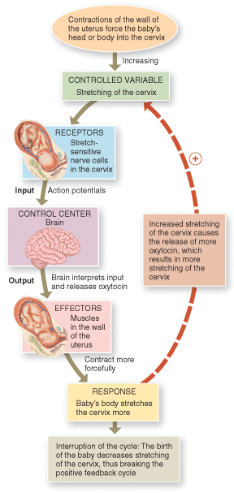

a) cervical stretch
b) action potentials in cervical nerve cells
c) oxytocin from the brain
d) the baby’s body pushing on the cervix

Answer: c

Difficulty: Easy
Bloom’s: Application
Learning Objective 1: LO 1.4 Explain how homeostasis is maintained in the body's internal and external environments.
Learning Objective 2: LO 1.4.5 Explain feedforward control.
Section Reference: 1.4 Homeostasis

53) Based on the graph, the greatest change in diastolic blood pressure occurred during
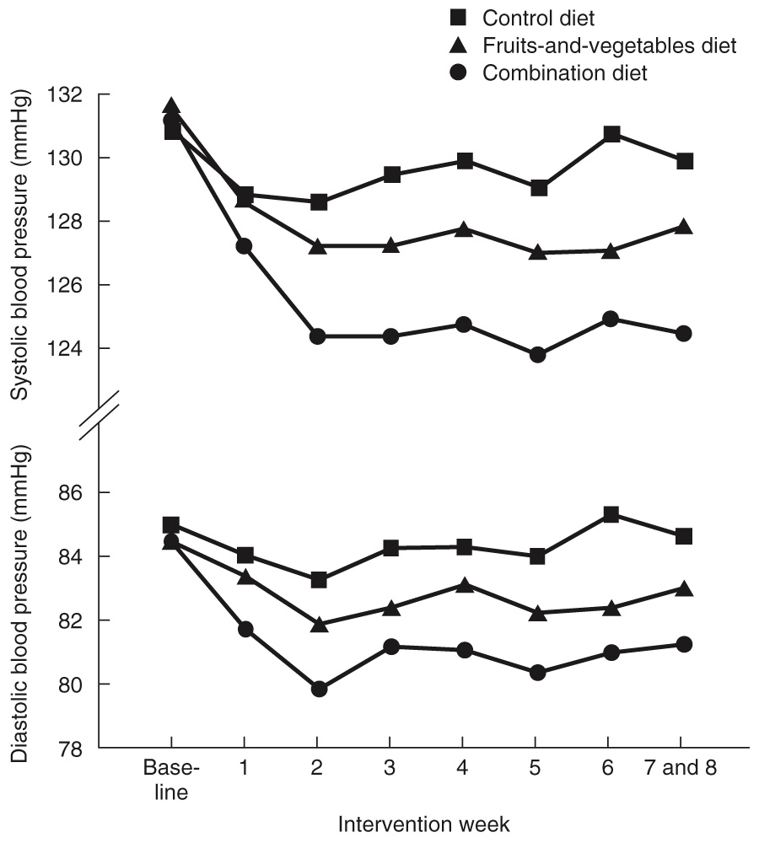

a) the first two weeks
b) the last two weeks
c) the fourth week
d) It is impossible to say, as the change appears to occur at a constant rate.

Answer: a

Difficulty: Medium
Bloom’s: Analysis
Learning Objective 1: LO 1.5 Explain the development of physiology as a scientific discipline.
Section Reference: 1.5 Physiology as a Science

54) Which systems work together with the respiratory system in the process of respiration?

a) cardiovascular and lymphatic
b) endocrine and renal
c) digestive and integumentary
d) muscular and nervous

Answer: d

Difficulty: Easy
Bloom’s: Knowledge
Learning Objective 1: LO 1.6 Identify the key themes of physiology.
Section Reference: 1.6 Key Themes of Physiology

55) Today the most detailed level at which physiologists are able to describe the mechanism of action is the

a) organ level
b) system level
c) molecular level
d) molecular and organ level

Answer: c

Difficulty: Easy
Bloom’s: Knowledge
Learning Objective 1: LO 1.6 Identify the key themes of physiology.
Section Reference: 1.6 Key Themes of Physiology

56) A chemical released into the blood fails to communicate with its receptor on/in a target organ or cell. You suspect there is an issue with a/an

a) neurotransmitter
b) local modulator
c) hormone
d) enzyme

Answer: c

Difficulty: Easy
Bloom’s: Comprehension
Learning Objective 1: LO 1.6 Identify the key themes of physiology.
Section Reference: 1.6 Key Themes of Physiology

