Student name:__________
TRUE/FALSE - Write 'T' if the statement is true and 'F' if the statement is false.
1) A bone contains nervous, connective, and epithelial tissue. Therefore, it is classified as an organ.
⊚ true
⊚ false

2) Surgical anatomy refers to the study of anatomic landmarks used before and after surgery.
⊚ true
⊚ false

3) The fact that the structures of cells vary widely reflects the specializations needed for their different functions.
⊚ true
⊚ false

4) Organs contain two or more tissues that work together to perform specific, complex functions.
⊚ true
⊚ false

5) The cell is the smallest living portion of the human body.
⊚ true
⊚ false

6) Fortunately for science, there is but one single property that defines life.
⊚ true
⊚ false

7) The life characteristic of reproduction may be interpreted at both the cellular and organismal levels.
⊚ true
⊚ false

8) The urinary system filters the blood, concentrates waste products, and removes waste products from the body.
⊚ true
⊚ false

9) The anatomic position allows all observers to have a common point of reference.
⊚ true
⊚ false

10) A coronal plane is a vertical plane that divides the body into anterior and posterior parts.
⊚ true
⊚ false

11) A sagittal plane is a vertical line that divides the body into right and left parts.
⊚ true
⊚ false

12) The chest is superior to the head.
⊚ true
⊚ false

13) The antecubital region is proximal to the carpal region.
⊚ true
⊚ false

14) The mediastinum is a serous cavity.
⊚ true
⊚ false

15) There is a physical barrier that separates the abdominal cavity from the pelvic cavity.
⊚ true
⊚ false

16) The sigmoid colon of the large intestine is contained within the hypogastric region.
⊚ true
⊚ false

17) The right and left iliac regions are found lateral to the hypogastric region.
⊚ true
⊚ false

18) The lumbar regions are located lateral to the umbilical region.
⊚ true
⊚ false

MULTIPLE CHOICE - Choose the one alternative that best completes the statement or answers the question.
19) The early anatomist who stressed the importance of experimentation in medicine and became known as the "Prince of Physicians" was
A) Galen.
B) Vesalius.
C) Pelops.
D) Leonardo daVinci.
E) Herophilus.

20) The artist who used dissections to improve his drawings and paintings was
A) Vesalius.
B) Galen.
C) Da Vinci.
D) Hippocrates.

21) Anatomy is the study of
A) function.
B) structure.

22) The scientific discipline that studies the function of body structures is
A) anatomy.
B) physiology.

23) Gross anatomy refers to the study of
A) cells.
B) structures formedby cells.
C) structures notvisible to the unaided eye.
D) structures visibleto the unaided eye.

24) The anatomic changes that result from disease are studied under
A) pathologicanatomy.
B) systemicanatomy.
C) histology.
D) surgicalanatomy.
E) developmentalanatomy.

25) Molecules are formed from two or more
A) electrons.
B) organs.
C) atoms.
D) tissues.
E) systems.

26) Which organizational level consists of related organs that work to achieve a common function?
A) Organ system level
B) Cellular level
C) Tissue level
D) Chemical level
E) Organ level

27) At what level of organization is a tooth?
A) Tissue level
B) Cell level
C) Organ level
D) System level
E) Atomic level

28) The term that refers to the ability of organisms to respond to a stimulus is
A) responsiveness.
B) reproduction.
C) metabolism.
D) development.
E) organization.

29) The smallest structural unit that exhibits the characteristics of living things is
A) an organ.
B) anindividual.
C) tissue.
D) a cell.
E) a system.

30) One of the characteristics of living things is ___________, which causes changes in structures, processes, or traits that increase expected long-term reproductive success.
A) adaptation
B) homeostasis
C) regulation
D) responsiveness
E) development

31) The various chemical reactions that organisms carry out are collectively called
A) metabolism.
B) homeostasis.
C) reproduction.
D) responsiveness.
E) development.

32) The system responsible for providing protection, regulating body temperature, and being the site of cutaneous receptors is the ____________ system.
A) respiratory
B) muscular
C) integumentary
D) urinary
E) nervous

33) The body system that provides support and protection as well as being a site of blood cell production (hemopoiesis) is the ____________ system.
A) skeletal
B) muscular
C) cardiovascular
D) respiratory
E) lymphatic

34) The system responsible for the exchange of gases between the blood and atmospheric air is the _____________ system.
A) urinary
B) respiratory
C) cardiovascular
D) endocrine
E) nervous

35) Which describes the anatomic position?
A) The body isupright.
B) Palms are facingforward.
C) Thumbs point awayfrom the body.
D) Feet are flat onthe floor.
E) All of the choices are correct.

36) The word _____ implies an imaginary flat surface passing through the body.
A) section
B) plane
C) direction
D) tangent
E) figure

37) A plane that passes through the structure at an angle is called
A) frontal.
B) coronal.
C) oblique.
D) sagittal.
E) transverse.

38) A _______ plane cuts perpendicularly along the long axis of the body or organ.
A) transverse
B) oblique
C) sagittal
D) coronal
E) frontal

39) Which best defines "superficial"?
A) On the inside
B) On the outside
C) Toward the end of an appendage
D) Close to the attachment of the appendage to the trunk
E) At the headend

40) The directional term that means "away from the midline of the body" is
A) inferior.
B) superior.
C) medial.
D) lateral.
E) caudal.

41) The directional term that means "closest to the point of attachment to the trunk" is
A) distal.
B) proximal.
C) medial.
D) cephalic.
E) dorsal.

42) The directional term that means "in back of or toward the back surface" is
A) posterior.
B) caudal.
C) cephalic.
D) anterior.
E) proximal.

43) The best term for referring to the rear or tail end is
A) caudal.
B) cephalic.
C) inferior.
D) superior.
E) lateral.

44) The head, neck, and trunk make up the ______ region of the body.
A) appendicular
B) axial
C) cephalic
D) caudal
E) thoracic

45) The posterior aspect of the body has _____ enclosed cavities.
A) 1
B) 2
C) 3
D) 4
E) 5

46) The cranial cavity houses the
A) eyeball.
B) ear canals.
C) brain.
D) spinal cord.
E) nasalstructures.

47) The bones of the vertebral column form a cavity called the
A) nervous systempassageway.
B) abdominalcavity.
C) spinalcavity.
D) vertebralcanal.
E) None of the choices are correct.

48) The axillary region is ______ to the pectoral region.
A) lateral
B) medial
C) distal
D) proximal
E) inferior

49) The anatomic term for the cheek is
A) buccal.
B) pelvic.
C) cervical.
D) crural.
E) sacral.

50) The best view of the popliteal region is seen from the
A) anterior.
B) lateral.
C) superior.
D) inferior.
E) posterior.

51) The anatomic term for the foot is
A) pubic.
B) patellar.
C) pes.
D) popliteal.
E) acromial.

52) The anatomic term for the wrist region is
A) tarsal.
B) carpal.
C) digital.
D) olecranal.
E) perineal.

53) One can best see the dorsum of the manus from a/n ______ view.
A) lateral
B) superior
C) inferior
D) posterior
E) anterior

54) The primary function of serous fluid is
A) to minimizefriction.
B) a stabilizingforce.
C) insulation.
D) energystorage.
E) to provide anattachment surface.

55) The anatomic term for the calf is
A) crural.
B) popliteal.
C) tarsal.
D) carpal.
E) sural.

56) The term "hallux" refers to the
A) littlefinger.
B) thumb.
C) great toe.
D) lateral-mosttoe.
E) middle digit.

57) The anatomic term for the hip region is
A) sternal.
B) coxal.
C) dorsal.
D) crural.
E) sural.

58) A piercing in the umbilical region would be found on the
A) curve of theear.
B) lip.
C) ear lobe.
D) navel.
E) eyebrow.

59) A professional fighter hit in the mental region might have damage to the
A) jaw.
B) ear.
C) nose.
D) knee.
E) shoulder.

60) Pollex refers to the
A) eyebrow.
B) thumb.
C) great toe.
D) littlefinger.
E) kneecap.

61) A digit may refer to
A) a finger.
B) the nose.
C) a toe.
D) the entirearm.
E) a finger ortoe.

62) An inguinal hernia is in the region of the
A) loin.
B) groin.
C) calf.
D) thigh.
E) shoulder.

63) Which is a physiological description rather than an anatomical one?
A) The muscles ofthe intestinal wall contract slowly and involuntarily.
B) The walls ofblood capillaries are composed of a thin epithelium.
C) The muscles ofthe thigh are composed of skeletal muscle tissue.
D) There arefenestrations (openings) between the epithelial cells in capillary walls.
E) The esophagealwall includes a middle layer of dense irregular connective tissue.

64) Which serous membrane covers the external surface of an organ?
A) The parietal layer
B) The visceral layer
C) The muscle layer
D) The dorsal layer
E) The ventrallayer

65) The limbs of the body are attached to the axis and make up the
A) abdominalregion.
B) thoracicregion.
C) axial region.
D) appendicularregion.
E) antebrachialregion.

66) The median space in the thoracic cavity is called the
A) pleuralcavity.
B) pericardialcavity.
C) mediastinum.
D) peritonealcavity.
E) pericardium.

67) Which is not found in the mediastinum?
A) Heart
B) Pancreas
C) Thymus
D) Trachea
E) Esophagus

68) The pericardium is a two-layered serous membrane that
A) encloses theheart.
B) encloses thekidney.
C) encloses alung.
D) provideslubrication for the knee.
E) covers the smallintestine.

69) With a specimen in the anatomic position, you can best see the mediastinum with a/an _____ view.
A) midsagittal
B) superior
C) inferior
D) anterior
E) posterior

70) The abdominopelvic cavity is commonly divided into _____smaller imaginary compartments or regions.
A) 6
B) 15
C) 8
D) 9
E) 18

71) The moist, two-layered serous membrane that lines the abdominopelvic cavity is called the
A) peritoneum.
B) diaphragm.
C) synovium.
D) pleura.
E) pericardium.

72) Of the abdominopelvic regions, the one that is the superior of the middle column is called the
A) lumbar.
B) umbilical.
C) epigastric.
D) hypogastric.
E) hypochondriac.

73) Which abdominopelvic regions have both a right and left side?
A) Lumbar and iliac
B) Hypogastric and hypochondriac
C) Hypochondriac, lumbar, and hypogastric
D) Iliac and hypochondriac
E) Lumbar, iliac,and hypochondriac

74) Lateral to the umbilical abdominopelvic region are the _____ regions.
A) hypochondriac
B) iliac
C) hypogastric
D) epigastric
E) lumbar

75) The urinary bladder is found in which abdominopelvic region?
A) Hypogastric
B) Right lumbar
C) Umbilical
D) Left iliac
E) Left lumbar

76) The gall bladder is typically found in the _____region of the abdominopelvic cavity.
A) umbilical
B) right lumbar
C) righthypochondriac
D) lefthypochondriac
E) hypogastric

77) The abdominopelvic quadrants are formed by passing one horizontal and one vertical line through the
A) patellarregion.
B) umbilicus.
C) antebrachialregion.
D) glutealregion.
E) cruralregion.

78) Which branch of microscopic anatomy is the study of tissues?
A) Histology
B) Cytology
C) Embryology
D) Developmental anatomy
E) Surgicalanatomy

79) Which branch of anatomy specifically examines developmental changes prior to birth?
A) Developmental anatomy
B) Regional anatomy
C) Embryology
D) Systemic anatomy
E) Pathologic anatomy

80) ______ anatomy examines both superficial anatomic markings and internal body structures as they relate to the skin covering them.
A) Regional
B) Surface
C) Radiographic
D) Surgical
E) Systemic

81) Which number corresponds to a sagittal plane?
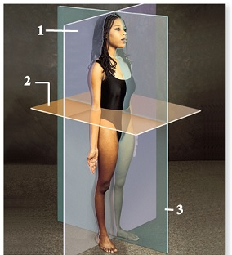
(c)McGraw-Hill Education/Joe DeGrandis, photographer
A) 1
B) 2
C) 3
D) None of the choices are correct.

82) Which number corresponds to a body cavity lined by serous membranes?
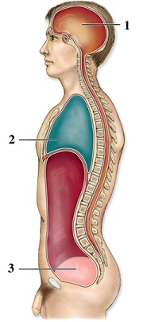
A) 1
B) 2
C) 3
D) None of the choices are correct.
E) All of the choices are correct.

83) Which number corresponds to a ventral body cavity?
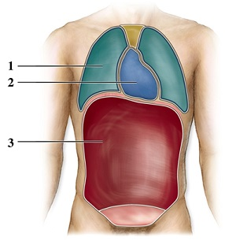
A) 1
B) 2
C) 3
D) None of the choices are correct.
E) All of the choices are correct.

84) Which number corresponds to the visceral layer of a serous membrane?
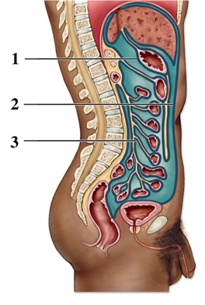
A) 1
B) 2
C) 3
D) None of the choices are correct.
E) All of the choices are correct.

85) A clinician makes a diagnosis before observing a patient's symptoms and completing a physical examination. This is the incorrect order of steps when following the scientific method. Which of the following describes how the process should have proceeded?
A) Collection of data comes before diagnosis.
B) Formation of a hypothesis comes after diagnosis.
C) Observation of symptoms comes after collection of data.
D) Formation of a hypothesis comes before observation of symptoms.

86) A physician orders a CT scan for a patient. Which step of the scientific method does this represent?
A) Collection of data
B) Formation of a hypothesis
C) Observation of symptoms
D) Diagnosis

87) The highlighted area is a portion of which body region?
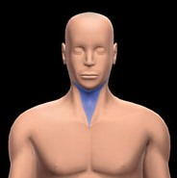
A) Thoracic
B) Cervical
C) Vertebral
D) Cranial

88) What direction is indicated in the image?
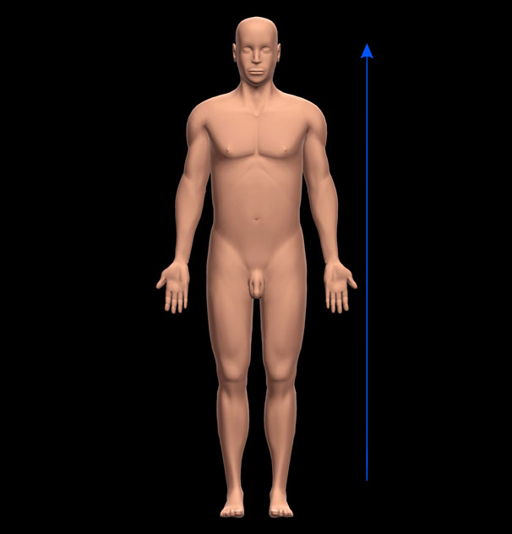
A) Caudal
B) Superior
C) Inferior
D) Proximal

89) What is the name of the highlighted membrane?
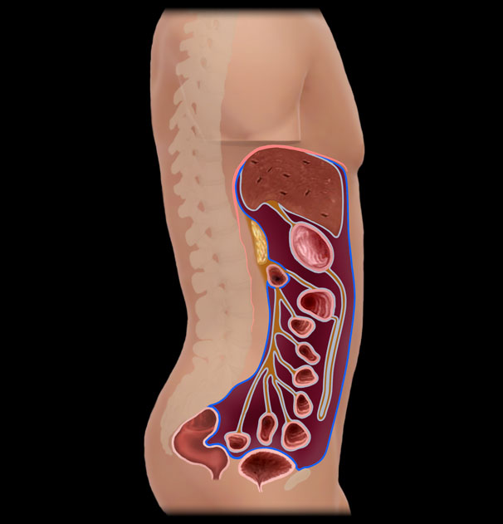
A) Parietalperitoneum
B) Visceral pericardium
C) Parietalpleura
D) None of the choices are correct.

90) What is the name of the highlighted body plane?
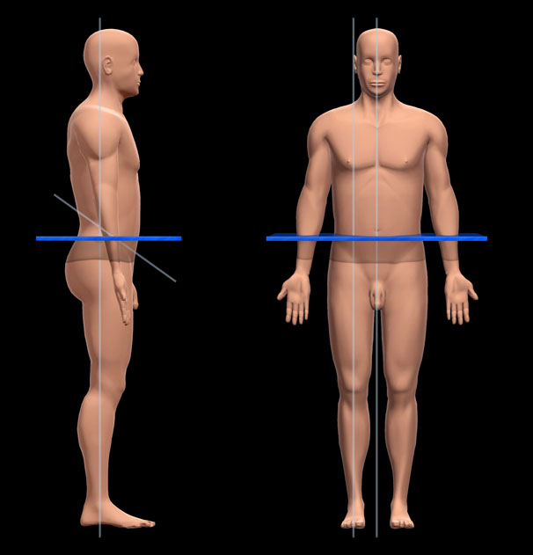
A) Transverse
B) Sagittal
C) Oblique
D) Coronal

91) What organ system are the highlighted organs part of?
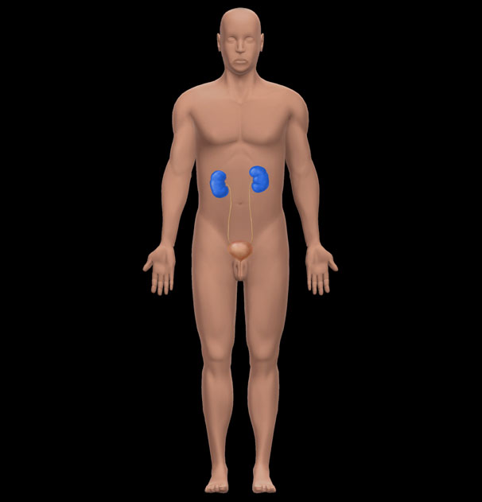
A) Endocrine
B) Lymphatic
C) Digestive
D) Urinary

FILL IN THE BLANK. Write the word or phrase that best completes each statement or answers the question.
92) The work of Greek scientist ________, who was the first to publicly dissect and compare human and animal bodies, greatly influenced Galen, the "Prince of Physicians."

93) The level of organization one step more complex than the organ level is the______ level.

94) The state of equilibrium, or constant interval environment, in the body is called ________.

95) The ______ system produces movement and generates heat when its parts contract.

96) The human organ system where the primary hormone is testosterone is the ______ reproductive system.

97) The ______ reproductive system produces oocytes.

98) The antecubital region is ______ to the brachial region.

99) The muscular partition that separates the thoracic and abdominopelvic cavities is the ______.

100) The hypogastric region is located ______ to the right iliac region.

101) The practice of using cross-sections of frozen cadavers developed in the 1900s. This field of study is called ________.

102) The preservation method where reactive polymers are embedded in each body cell is called ________.

Answer Key
Test name: chapter 1
1) TRUE
2) TRUE
3) TRUE
4) TRUE
5) TRUE
6) FALSE
7) TRUE
8) TRUE
9) TRUE
10) TRUE
11) TRUE
12) FALSE
13) TRUE
14) FALSE
15) FALSE
16) TRUE
17) TRUE
18) TRUE
19) A
20) C
21) B
22) B
23) D
24) A
25) C
26) A
27) C
28) A
29) D
30) A
31) A
32) C
33) A
34) B
35) E
36) B
37) C
38) A
39) B
40) D
41) B
42) A
43) A
44) B
45) B
46) C
47) D
48) A
49) A
50) E
51) C
52) B
53) D
54) A
55) E
56) C
57) B
58) D
59) A
60) B
61) E
62) B
63) A
64) B
65) D
66) C
67) B
68) A
69) D
70) D
71) A
72) C
73) E
74) E
75) A
76) C
77) B
78) A
79) C
80) B
81) C
82) B
83) E
84) A
85) A
86) A
87) B
88) B
89) A
90) A
91) D
92) Herophilus
93) organ system
94) homeostasis
95) muscular
96) male
97) female
98) distal
99) diaphragm
100) medial
101) cryotechnology
102) plastination

